Sample Section 3 Service Area
Example 1 – Project located within Hillsboro, Texas – the Hillsboro city limits are indicated in blue on the map below.
Step 1: Identify the mid point of the project site – the water line project location on the map below is marked in blue, and the midpoint is indicated with a red cross.
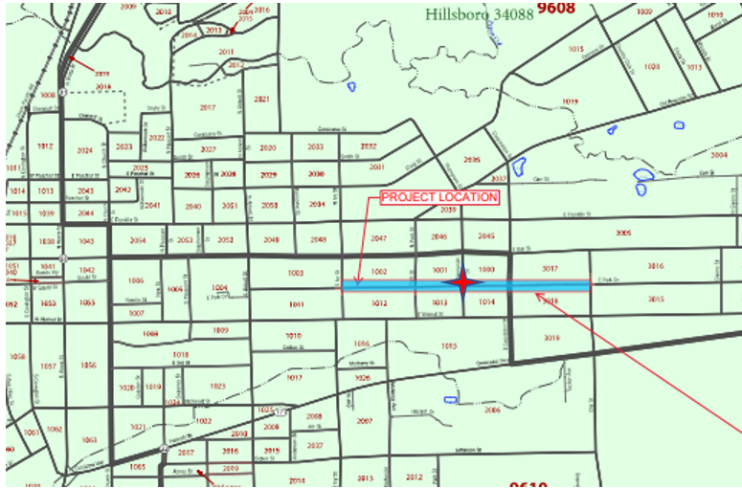
Identify a circle around the center of the project site with a radius of 1 mile. In the example below, the red circle marks the area within one mile of the point marked by the red cross.
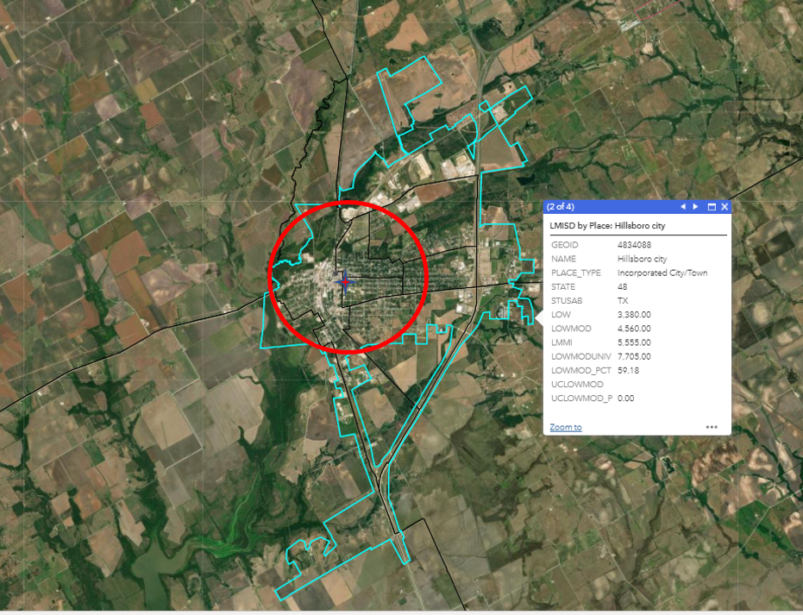
In this example, the population of Hillsboro is reported by LMISD data as 7,705 persons, most of which reside within the identified circle. Since the population within one mile of the project site exceeds 5,000 persons, the Section 3 Service Area is defined by the red one-mile circle.
Example 2 – Project located northwest of Eden, Texas – the Eden City limits are indicated in blue on the map below.
Step 1: identify the midpoint of the project site and create a circle around the center of the project site with a radius of 1 mile:
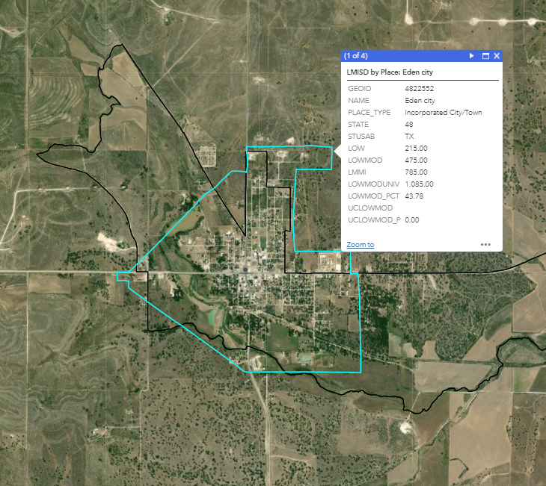
In this example, the city limits for the “place” are indicated in blue, and the project is marked with the red cross. The red circle marks the area within one mile of the project site. The Population within the circle is clearly less than 5,000 persons, so continue to Step 2.

Step 2 – aggregate census block group geographies totaling a minimum of 5,000 persons that both
- surrounds all components of a Project Site, AND
- most closely approximates a circle shape.

At this time, no HUD tools have been provided to assist with this process. If the Grant Recipient or its service providers do not have other available tools, TDA recommends using the LMISD Mapping Application, normally used to identify beneficiary populations, to visually identify block groups to be included.
Low- and Moderate-Income Summary Data, based on 2011-2015 ACS - Overview (arcgis.com)

In this example the following Block Groups make up the “circle”:
Census Block Group | LOWMODUNIV
Concho County (all BG) | 2685
McCulloch Co Block Group 1 | 655
Menard Co Block Group 1 | 465
Tom Green Co Block Group 4 | 1330
Total Population | 5135

