SECTION B
PLANNING

TABLE OF CONTENTS

Page

B.0 Introduction 2
B.1 Planning Procedures – Step-by-Step 3

SECTION B
PLANNING

B.0 Introduction

This section addresses the steps necessary to successfully implement planning grants awarded through the Planning and Capacity Building Fund or the Colonia Fund of the Texas Community Development Block Grant Program (TxCDBG). This section is not intended to replace the other sections of the TxCDBG Project Implementation Manual; rather, it is to serve as a guide in accomplishing the administrative requirements specific to planning grant recipients.

Planning is an organized way of preparing for the future. It helps accommodate and integrate competing interests to meet expected change, produce desired change and prevent undesirable change. It provides a guide and alternative solutions to problems. It is a process and technique for setting policies and enforcing them in a coordinated fashion. A community with a plan is likely to appear generally more attractive, particularly considering that a good part of the economic development process is marketing.

Grant Recipients that have executed grant agreement for planning activities must follow the administrative procedures outlined in the following chapters of Section A:
- Chapter 1: Administration and Reporting;
- Chapter 2: Financial Management;
- Chapter 3: Environmental Review;
- Chapter 5: Procurement Procedures;
- Chapter 10: Civil Rights Requirements;
- Chapter 11: Grant Amendments;
- Chapter 13: Monitoring; and
- Chapter 14: Audit Requirements.

In addition to the procedures and requirements outlined in these chapters, this Section B includes specific requirements for planning activities.

Please refer to the TDA website for sample documents provided as guidance in meeting program requirements.

B.1 Planning Procedures

Step 1. Submit Environmental Documentation
The Grant Recipient may not incur costs or expend any grant funds for project activities before meeting all environmental review and special condition requirements in the TxCDBG grant agreement.
The environmental documentation must be completed before planning activities begin. See Chapter 3 Environmental Review for further information on fulfilling environmental clearance requirements of the planning grant.

Step 2. Procure a Planner or Designate Staff
The Grant Recipient must competitively procure a planner, or designate qualified local staff to complete the planning activities, prior to beginning work on the planning activities.

Competitive Proposal Procurement
The Competitive Proposal/Request for Proposal (RFP) process must ensure a competitive process, adequate scope of work, and compliance with all applicable federal and state procurement laws and regulations.

The Grant Recipient must verify the contractor’s SAM registration is active and confirm their eligibility through the System for Award Management (SAM) www.SAM.gov. See also Chapter 5. Registration and eligibility of all contractors must be verified through the SAM website prior to any formal action authorizing the award of the contract to the contractor. Examples of formal action include but are not limited to, authorizing resolution, authorizing ordinance, council approval of award, contract execution, etc.

See Chapter 5. Procurement procedures for further information on fulfilling competitive proposal procurement requirements. Sample RFP documents are found in Appendix D
- The RFP must be published in a local newspaper and sent to at least five firms.
- Either a fixed price or cost reimbursable type contract must be awarded.
- Retainer contracts or any semblance of a retainer contract are not allowed.
- BEST PRACTICE: If negotiations are necessary for the successful procurement of a planning consultant, the negotiations should focus on the specific scope of services to be provided, terms and conditions of the contract, time frames for accomplishment of activities, and the amount of compensation for each activity.

In order to be eligible for TxCDBG grant funding or match funding, or both, costs incurred during the
pre-agreement phase must be incurred:
- After the TDA pre-agreement date (application due date);
- After the planning services contract award date (formal approval by elected body); and
- During the contract period identified in the planning services contract (Time of Performance in the implementation manual Appendix D and E, sample contract)—the services contract period may begin prior to the date that the services contract was executed.

The cost of procuring the professional planning services is an administrative cost and is not an eligible cost for TxCDBG grant or local matching funds.

Force Account
If the Grant Recipient has a planning department that will perform the planning activities, thorough records are required. The recordkeeping requirements as well as what costs are allowable are discussed in Chapter 8 Force Account Labor. NOTE: Administration activities are not eligible for reimbursement planning activities.

Step 3. Set up Administrative Procedures and Submit Initial Documentation
BEST PRACTICE: A recommended filing system to meet TxCDBG monitoring requirements for planning grants is included. See Sample Grant Recipient File System–Planning Projects (Form B2).

See Chapter 1 Administration and Reporting for additional information on administrative procedures and reporting.

The following documentation must be submitted within six months of the TxCDBG grant agreement start date:
- Environmental Performance Report;
- Materials & Service Report (MSR) for planning services;
- All Group A documentation identified in Chapter 1 Administration and Reporting Section 1.1.4. Grant Recipients must conduct an acceptable activity to affirmatively further fair housing during the grant period.

At least once per calendar quarter, the Grant Recipient must initiate a new Performance Report. Select the Current Status reporting option and complete each response. Select Submit Performance Report in the Status Options section of the navigation menu.

Quarter | Report Due
January – March | April 20
April – June | July 20
July – September | October 20
October -– December | January 20

Step 4. Perform Planning Activities
The specific planning activities required by the grant are stated in the TxCDBG grant agreement (Exhibit A) Performance Statement.

A completed planning document must include
- a cover letter from the chief local official, which specifically states
- the locality finds all planning reports and maps acceptable for its needs; and
- the locality has in its possession all products, including reproducible maps, and computer compact discs (CDs) containing Adobe Acrobat and original vector map data, if applicable, with instructions for retrieval.
- itemization and/or description of the location of each requirement of this performance statement within each report to include chapter, page and paragraph;
- inventory and plan maps for each element requiring mapping;
- high quality planning document, exported in Adobe Acrobat portable document format (PDF), that contains the narrative and mapping prepared under the grant, as well as source map data (original vector data) and graphic data, labeled with the locality name, grant number, planning period covered by the report, topics included within the CD report (on the CD), and preparer’s name and date of preparation; and
- itemization and/or description of the content and layout of the data files and the name of the software package(s) used to generate the maps. One type of mapping software shall be used for all maps required under this grant. Data files must be compatible with computer systems owned or readily available to the local government.

All reports, maps, and other products completed as a part of this grant, other than documents prepared exclusively for internal use within the TDA, shall carry the following notation on the front cover, CD label, or a title page and on the face of maps:

FINANCED THROUGH TxCDBG – OFFICE OF RURAL AFFAIRS OF THE TEXAS DEPARTMENT OF AGRICULTURE. The preparation of this document was financed through provisions of a Texas Community Development Block Grant Program (TxCDBG) Grant from the U.S. Department of Housing and Urban Development.

The planning document must include the following disclaimer:

Texas Department of Agriculture (TDA) in conjunction with the United States Department of Housing and Urban Development furnished financial support to the activity described in this publication which does not necessarily indicate the agreement of TDA or of the United States Department of Housing and Urban Development with the statements or conclusions contained in this publication.

Step 5. Amend the TxCDBG Grant (optional)
During the course of the TxCDBG grant, situations may occur that require a change in the original terms of the grant agreement. See Chapter 11 Grant Amendments for general procedures for amending or modifying TxCDBG grant agreements.

All costs are paid on a reimbursement for services basis.

Step 6. Accept the Planning Documents
Once all planning activities are completed, the Grant Recipient must formally review and accept the planning documents:
- Final Public Hearing: Local officials must review the final planning documents during a public meeting. Over the course of the grant, including the final public hearing, local officials must spend a minimum of one (1) hour reviewing the planning documents and must certify the completion of this requirement by resolution (see below).
- Final Public Hearing Notice: In addition to the information required for all public hearing notices, the notice of final public hearing for planning activities must state that the planning documents prepared under the TxCDBG grant are available for review at least twelve (12) days prior to the final public hearing.
- Resolution: The Grant Recipient must pass a local resolution after the final planning product is presented to the governing body, which states:
- Local officials’ participation in preparing and reviewing planning documents for local needs, grant compliance, and the final presentation of the plan at the final hearing and/or meeting met or exceeded a one-hour minimum requirement set forth by this grant;
- Goals and objectives developed for each grant agreement planning element were presented, discussed, reviewed and established by local officials;
- Inventory, analyses, plans and maps associated with them required under the grant were presented, discussed and reviewed by local officials;
- Capital needs listed and ranked within the reports were presented, discussed, and reviewed by local officials;
- Opportunities were provided for citizen participation in the planning process;
- Local review established that the planning documents are suitable as policy guides for the Grant Recipient;
- Local efforts in plan(s) preparation were intended to eliminate impediments to fair housing and support equitable distribution of the plans’ benefits;
- Grant agreement planning documents are accepted by the Grant Recipient as substantiation for payment requisition to TDA, and for the Grant Recipient’s payment to its consultant(s); and
- A statement of how the Grant Recipient intends to use its planning documents prepared under the grant.

See Chapter 1 Administration and Reporting Section 1.1. for detailed instructions regarding public notices and documentation, including those for public hearings.

Step 7. Request Payment for Completed Planning Activities
See Chapter 2 Financial Management for general procedures for requesting payment under TxCDBG grant.

For payments on planning activities, the following additional requirements apply:
- Funds are released only for completed planning documents. Backup documentation for all payment requests must include a copy, both printed and electronic, of the completed planning element(s) being claimed and written confirmation from the chief local official that the completed element has been reviewed and accepted by the Grant Recipient.
- Upload the following support documentation:
- Complete final planning document. See Step 4.
- Local resolution accepting planning documents. See Step 6.
- Invoice for planning services.
- Engineering and/or architectural services, administrative services, and audit services are not eligible costs.
- Unless otherwise approved by TDA staff, a single Payment Request is expected for each planning grant.

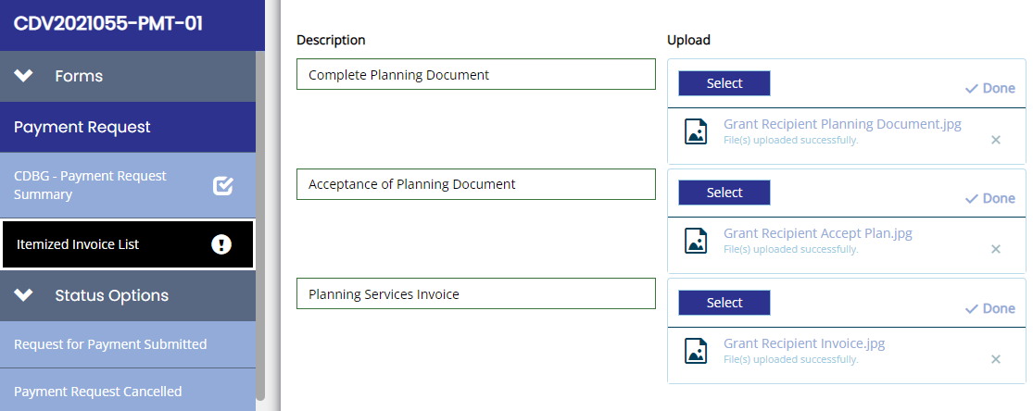

Figure 1. Upload support documentation in TDA-GO

Step 8. Submit Closeout Documentation
Once all planning activities are completed and accepted, the Grant Recipient must change the status of the grant in TDA-GO by selecting the Begin Closeout option. See Chapter 12 for additional guidance on completing the closeout page.

Step 9. TDA Compliance Monitoring
TxCDBG grants for planning activities will be monitored for compliance with federal, state, and program requirements through a desk review. This includes review of all written project data, including, but not limited to
- evidence of timely disbursement of grant and match funds in the form of bank statements showing when the grant funds were deposited, when the checks were written, and copies of cancelled checks;
- the Grant Recipient’s application;
- progress reports;
- payment requests;
- written correspondence;
- copies of audits; and
- documentation of previous monitoring.

A copy of the monitoring checklist and review criteria Planning Fund Monitoring Checklist (Form B13) is provided to be used as a guide to monitor grant performance. TDA retains the right to modify monitoring procedures and tools as deemed necessary.

See Chapter 13 Monitoring for additional information on monitoring procedures and administrative completion of the grant.

