CHAPTER 2
FINANCIAL MANAGEMENT

TABLE OF CONTENTS

Page
2.0 Introduction 2
2.1 Accounting Procedures 2
2.1.1 Establish Internal Controls 2
2.1.2 Establish/Maintain Document Files and Records 2
2.1.3 Establish Responsible Persons 2
2.1.4 Establish Grant Account with TDA 2
2.1.5 Understand the Grant Agreement and Detailed Budget Summary Table 2
2.2 Thresholds for Fund Disbursement 2
2.3 Matching Funds 2
2.3.1 Acceptability of Matching Funds 2
2.3.2 Reducing the Commitment of Matching Funds 2
2.3.3 Matching Funds Provided by Other Funding Agencies 2
2.4 Payment Request Procedures 2
2.4.1 Submitting a Payment Request 2
2.4.2 Minimum Payment Request Amounts and Disbursement 2
2.4.3 Delays, Ineligible Costs, and Denial of Payment 2
2.4.4 Payment Revisions 2
2.5 Program Income 2
2.6 Investigation of Fraud Allegations 2

CHAPTER 2
FINANCIAL MANAGEMENT

2.0 Introduction

The Grant Recipient must review the financial requirements of the agreement and set up a financial accounting system consistent with the requirements of the TxCDBG program. The financial requirements for local governments receiving TxCDBG funds are governed by regulations issued by the United States Department of Housing and Urban Development (HUD), the Federal Office of Management and Budget (OMB), and federal, state, and local policy.

TDA’s TxCDBG program is responsible for monitoring the Grant Recipient’s compliance with applicable financial management standards, for processing payment requests in TDA-GO for TxCDBG funds, and for audit review. Federal regulations governing financial management include 24 CFR Part 570 Subpart I, which governs the state TxCDBG program, Section 570.489 which details program administration requirements, and select parts of Section 2 CFR Part 200—including all of Subpart E Cost Principles.

2.1 Accounting Procedures

The Grant Recipient is responsible for ensuring that all TxCDBG expenditures are authorized in the approved budget. Separate accounting records must be maintained for TxCDBG project funds (i.e., separate from the general municipal/county funds).These records should be developed and maintained to be consistent with the Grant Recipient's general accounting records.

Grant Recipients must take the following steps to ensure an adequate local accounting system for TxCDBG funds.

2.1.1 Establish Internal Controls

The Grant Recipient should establish internal controls that provide for responsible management of TxCDBG funds. The system of internal controls should meet the following criteria:
- All federal, state, and local conflict of interest provisions apply;
- The foundation of a good internal control system is the segregation of duties. The duties of authorization (signing a check or releasing a wire transfer), custody (having access to the blank check stock or the ability to establish a wire transfer), and recordkeeping (ability to record the transaction in the accounting system) should be separated so that one individual cannot complete a transaction from start to finish. No person should ever have complete control over every phase of a transaction.
  - The person who authorizes payments to contractors should not draft and issue the payment checks.
  - The local government should require at least two signatures on checks.

- Best practices also provide that fiscal record keeping for TxCDBG agreements should be maintained separately from the general accounting operations.
- Where feasible, monthly bank reconciliation and/or direct deposit monthly statements should be made by someone who is not responsible for handling cash or issuing checks; and
- The person issuing checks for grant expenses should not also handle payroll preparation or issuance of paychecks.
- Other internal controls may include reviewing randomly selected transactions and their supporting documentation, taking periodic asset counts, or checking financial reconciliations.

State law and the charters of home rule cities contain fidelity bond requirements for certain city and county officials. For their own protection, TDA recommends that all Grant Recipients additionally obtain a fidelity bond for each employee or official having access to project assets, accounting records, or checks.
  - The bond, either position or blanket type, should be in an amount at least equal to the total project assets that would be available to the project at any time. TDA may require adequate fidelity bond coverage where the Grant Recipient lacks sufficient coverage to protect the federal government's interest.
  - If the latter requires an additional premium to be paid on the Grant Recipient's existing policy, this extra cost can be reimbursed out of the general administration budget category of the TxCDBG grant agreement.

2.1.2 Establish/Maintain Document Files and Records

TxCDBG grant funds must be carefully tracked and documented. BEST PRACTICES: TDA strongly recommends that the Grant Recipient establish a separate, non-interest-bearing bank account for grant and local match funds.
- If the Grant Recipient chooses to deposit grant funds into an interest-bearing account, contact TDA. See 2 CFR § 200.305(b)(9) for additional regulations for interest-bearing accounts.
- If the Grant Recipient elects not to use a separate account, separate financial records must still be maintained in addition to the Grant Recipient’s general accounting operations and must be available upon request by TDA or other relevant agencies.
- If the Grant Recipient elects not to use a non-interest-bearing account, any interest earned as a result of deposited grant funds may be required to be returned to the federal Treasury.

Financial Records Must Include the Following:
- Transaction Register – The Grant Recipient’s TxCDBG financial records must include a log documenting all costs and transaction dates in sequential order by payment request.
- The log must include dates of deposited grant funds, the name of the vendor/service provider, the invoice number or similar identifier, total costs incurred for the payment, source of funds (grant reimbursement, matching funds, additional local/other funds), the Grant Recipient’s check number disbursing funds, the check dates, and the dates of posted payments for each disbursement according to bank records.
- Although some of this information may be submitted in each payment request, it is the responsibility of the Grant Recipient to maintain the complete financial transaction register.

- Source documentation, including the following:
- Record of direct deposit payments;
- Verification of deposits;
- Monthly bank statements with canceled checks;
- Check register/transaction ledger;
- Employee time and attendance sheets related to costs claimed;
- Equipment time record sheets related to costs claimed;
- Property inventory;
- Deeds, easement documents, and purchase agreements for acquisition of property;
- Purchase orders, invoices, receipts, and contractor requests for payments; and
- All original source documents.

Financial records must clearly identify costs within the following categories:
- Costs requested for reimbursement through grant funds;
- Costs to be claimed as matching funds, paid by the Grant Recipient or a partnering entity; and
- Costs to be paid by local funds that exceed the grant agreement match amount or otherwise are not being claimed against the match commitment.

2.1.3 Establish Responsible Persons

The Grant Recipient must identify by resolution the persons (BEST PRACTICE: Identify persons using position titles) authorized to execute payment requests.
- An authorized official within the TDA-GO system must assign the role payment processor to each of these individuals.
- Signatures of at least two payment processors are required for each.
- The TDA-GO roles and/or resolution must be updated when a payment processor changes due to elections, illness, resignations, etc. See Sample Resolution (Appendix V).
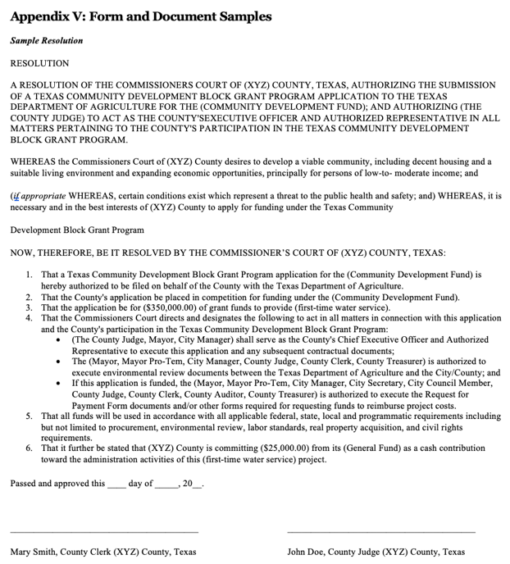

Figure 1. Sample Resolution in Appendix V

2.1.4 Establish Grant Account with TDA

As part of the grant award process, TDA must establish the account to which grant funds will be disbursed. No grant agreement will be issued until this information is received.
- Federal Request for Taxpayer Identification Number (Form W9) – All Grant Recipients must have an updated federal W9 on file.
- State Application for TIN – Provided by the Texas Comptroller of Public Accounts, a new or updated TIN form is required for each grant award. If the TIN form uploaded to the TDA-GO organization page is accurate, the Grant Recipient may confirm this information during the pre-award call.

Upload current W9 and TINS forms to the Grant Recipient’s TDA-GO Profile, Organization Details page to avoid repeated submissions if the Grant Recipient receives multiple grants.
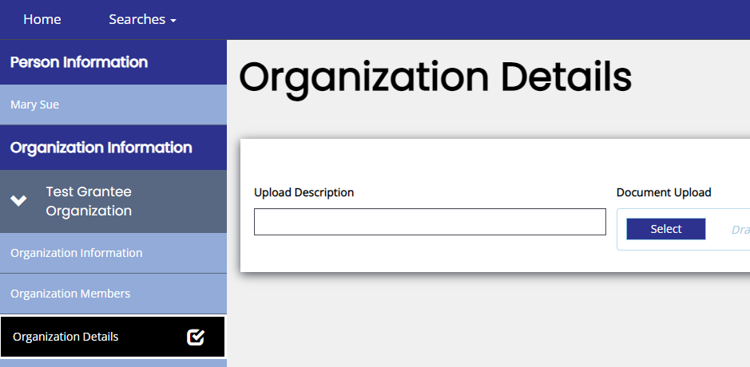

Figure 2. Upload all necessary documentation in Organization Details

- Direct Deposit Authorization Form (Form 74-176) – Provided by the Texas Comptroller of Public Accounts, a separate 74-176 form must be completed for each grant award.
  - TDA does NOT currently request unredacted bank account information to be submitted within TDA-GO. Email a completed form for each TxCDBG grant to CDBGReporting@TexasAgriculture.gov prior to executing the grant agreement, and any time the banking information changes.
  - The Grant Recipient is strongly encouraged to receive payments from TDA posted directly to the local bank account. Grant payments released after the form is submitted and processed will be deposited using this method; allow 30 days for processing.
  - If the Grant Recipient declines to participate in direct deposit options, manually strike through Sections 3, 4, and 6 of the form and write in Warrant Requested.

2.1.5 Understand the Grant Agreement and Detailed Budget Summary Table

The Grant Agreement Exhibit B contains a basic project budget to which the Grant Recipient must adhere. Exhibit B identifies specific grant funded activities with their associated budgets, as well as the total amount of funds committed as match.

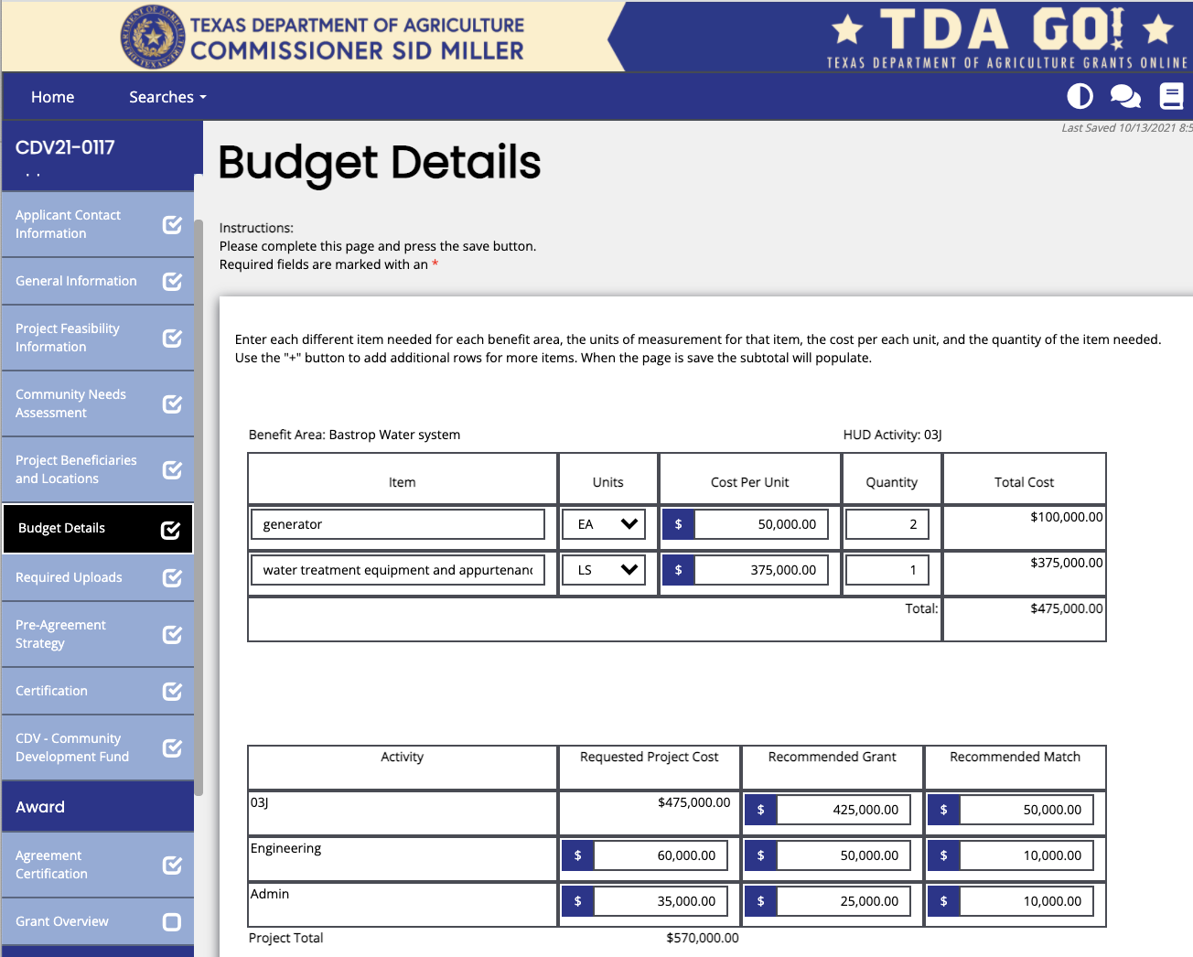
Figure 3. Sample of Budget Details

The match commitment is not contractually assigned to specific budget lines, but the Grant Recipient may view the recommended budget lines for matching funds by navigating to the application budget details page.

2.2 Thresholds for Fund Disbursement

TDA requires certain documents to be submitted to TDA to meet required thresholds prior to releasing several categories of grant funds. Additional documentation may be required based on the specific fund category or project description and will be listed in the TxCDBG grant agreement.

General Requirements
- Disbursement thresholds describe the period where funds may be requested, but do not prevent the Grant Recipient from continuing to incur costs.
- Regardless of any thresholds that may impact disbursement of funds, all costs must be incurred within the agreement period, except:
  - Costs approved under written pre-agreement strategy approval;
  - Administrative costs incurred up to 60 days after the grant agreement end date; or
  - Administrative costs for preparation of a single audit, as described in Chapter 12.
- All requested documents must be uploaded directly to TDA-GO and approved by TDA. Documents will not be accepted by email or other method unless previously approved by TDA staff.

Maximum General Administrative and Engineering Services Reimbursement
The TxCDBG grant application guide describes the maximum allowable expense for administrative and engineering costs for each particular fund category and/or competition. Unless specifically stated otherwise:
- The administrative costs may not be more than 16% of the TxCDBG grant funds budgeted for (or expended for) combined construction and acquisition/relocation activities, or the maximum dollar amount, whichever is less.
- Engineering costs may not be more than 25% of the TxCDBG grant funds budgeted for combined construction and acquisition/relocation activities (except in exceptional circumstances), or the maximum dollar amount, whichever is less.

Adjusted Administration and Engineering Services Reimbursement when Funds are Deobligated
- If construction and/or acquisition funds are deobligated from the grant agreement during the closeout process, the ratios for administrative and engineering costs will be recalculated to ensure that final costs are within the allowable percentage of the actual construction and acquisition/relocation grant funds utilized. Any costs more than the recalculated ratios will be considered over budget. The Grant Recipient may not request payment for over budget costs and must repay any such costs already received—but may claim these costs to meet a grant agreement’s match requirements.
- Grant Recipients deobligating construction and/or acquisition funds may request an exception to the recalculated budgets for administration and engineering services if the project was completed during the original grant agreement period, i.e., no extensions. The request letter must be uploaded to the Grant Overview, Special Requests section, and must include a description of:
  - Unforeseen circumstances beyond the Grant Recipient’s control;
  - The timely and effective completion of contractual project obligations in their professional/administrative service agreement;
  - Additional time invested in the project beyond the normal scope of work; and
  - Good faith efforts by the Grant Recipient and the administrative or engineering services provider to use allowable grant amendment options to fully utilize the grant funding included in the TxCDBG grant agreement.
For the following thresholds, see Chapter 1 for a list of requirements:

Group A Documents
No grant funds will be disbursed until Group A documents have been accepted.

Once all Group A requirements have been approved by TDA staff, the Grant Recipient may request the following, as costs are actually incurred:
- Up to 50% of the administrative budget, and
- Up to 50% of the engineering budget.

Group B Documents
Once all Group B requirements have been approved by TDA staff, the Grant Recipient may request the following, as costs are actually incurred:
- Up to 90% of the administrative budget,
- Up to 90% of the engineering budget, and
- Up to 95% of the construction activity budget(s).

NOTE: Construction Retainage for Multiple Contractors
In addition to the grant budget funding retention for the overall construction activity(s), Grant Recipients that have awarded multiple construction agreements must retain at least 5% of each prime agreement. However, TDA will allow release of this retainage upon completion of the TDA-GO MSR for a specific contractor, so long as 5% of the total construction activity budget line is retained until all Group C requirements are satisfied.

The Grant Recipient must ensure that contractors have satisfactorily fulfilled all provisions of the construction agreement, including resolution of any punch list items, the clean-up phase of the project, and payment of any payroll restitution or liquidated damages owed in accordance with Davis-Bacon and Related Acts.

Group C Documents
Once all Group C requirements have been approved by TDA staff, the Grant Recipient may request the following, as costs are actually incurred:
- Up to 100% of the engineering budget; and
- Up to 100% of the construction activity budget(s).

Group D Documents
Once all Group D requirements have been approved by TDA staff, the Grant Recipient may request up to 100% of the administrative budget.

The payment request for the final administrative costs must be submitted no later than 60 days after the agreement end date, and BEFORE submission of Project Completion Report. The TDA-GO Payment Request cannot be submitted once the closeout process is begun, though final approval of the payment may occur after the grant agreement is determined to be administratively complete. See Chapter 12.

Summary of Funding Thresholds | Grant Budget Available
General Administration Grant Budget
Acceptance of all Group A documents | 0 to 50%
Acceptance of all Groups A and B documents | 51 to 90%
Acceptance of all Group D documents (approved after Issuance of Administratively Complete  notice by TDA) | 91 to 100%
Engineering Grant Budget
(Multiple line items may be considered cumulatively to determine thresholds)
Acceptance of all Group A documents | 0 to 50%
Acceptance of all Group A and Group B documents | 51 to 90%
Acceptance of all related Certificate(s) of Construction Completion  and any regulatory approvals required by the grant agreement, such as Texas  Commission on Environmental Quality (TCEQ) interim well approvals or Texas  Department of Licensing and Regulation (TDLR) inspections | 91% to 100%
Construction Grant Budget(s)
Acceptance of all Group A and Group B documents | 0 to 95%
Acceptance of all Group A, Group B, and Group C documents | 96% to 100%

2.3 Matching Funds

Matching funds are defined as actual revenues provided by the Grant Recipient or other units of local government in a joint application, as committed in the Grant Agreement. TDA incentivizes projects that contain matching funds and expects Grant Recipients to meet their match commitments. Requests to claim force account costs as match funds must comply with Chapter 8.

2.3.1 Acceptability of Matching Funds

Funds can be considered as matching funds only if the matching funds will be used for:
- activities described in the TxCDBG Performance Statement (Exhibit A of the TxCDBG grant agreement); or
- activities that are directly related to supporting the activities proposed for TxCDBG funding.

Match can be considered only if the Grant Recipient has used an acceptable and reasonable method to document the value of the match. Except for cash match, the Grant Recipient must submit a schedule which shows how the value of each type of match was determined. Please note that local match can only be counted for expenditures that would not occur if the TxCDBG grant agreement were not funded. Local match will only be considered for expenses that meet the eligibility and prior approval requirements of TDA.

Cost Eligibility
Matching funds are subject to all TxCDBG cost eligibility requirements, except that the following items are not eligible for grant funding but may be eligible for matching funds:
- Donated Property – The value of property owned by either the Grant Recipient or the utility that will own new grant-funded facilities, excluding easements, rights-of-way, existing locations for the same infrastructure system, or similar property, may be claimed as matching funds as long as the donated property changes hands, i.e., a city cannot donate property to itself as a match.
- Waived Fees – Fees associated with grant or match funded infrastructure that are normally collected by either the Grant Recipient or the utility that will own the infrastructure but that are waived for the TxCDBG project may be claimed as matching funds with prior TDA approval. These fees may include assessment fees, capital improvement fees, utility connection fees for low- to-moderate-income households, and similar fees.
- First-time Water/sewer Service for Non-LMI Households – At TDA’s discretion, costs associated with yard lines for non-LMI households may count as matching funds.

Federal, State, and Program Requirements
Matching funds are generally subject to all TxCDBG program requirements. However, the following exception applies:
- For construction agreements funded entirely through non-TxCDBG funds but used to complete the TxCDBG project, the construction agreement may be exempt from Davis-Bacon and related requirements. See Chapter 7.

2.3.2 Reducing the Commitment of Matching Funds

Each Grant Recipient is required to expend the same ratio of local funds to TxCDBG funds as documented in the Grant Agreement.

If the overall project costs are less than the budgeted funds, the Grant Recipient may proportionally reduce both the grant fund and matching fund amounts without a budget amendment. The formula for calculating a proportional reduction in grant and match funds is:

Total Project Cost ÷ (1 + (Exhibit B Match Amount ÷ Exhibit B Grant Amount)) = Adjusted Grant Funds

The TxCDBG Match Calculator (Form A208) on the TDA website to assist in calculating the correct ratio of grant and match funds based on actual project costs.

Unless the terms of the award or fund category require a larger match ratio, TDA will not require or verify matching funds greater than 100%.
- For projects in which the local match commitment exceeds the amount of TxCDBG grant funds, the matching funds may be reduced to the point that local funds are equal to or greater than the TxCDBG grant funds expended on the project without reducing grant funds.
- Approval from TDA to proportionally reduce matching funds is required if the overall project costs are proposed to be reduced by deleting work from the TxCDBG grant agreement Performance Statement in Exhibit A. The project also requires a grant amendment. See Chapter 11.

2.3.3 Matching Funds Provided by Other Funding Agencies

If matching funds for a TxCDBG project are provided by other federal or state sources, the Grant Recipient must document those matching funds according to the rules and regulations of the funding agency from which the funds are requested. The Grant Recipient must submit documentation of the following to TDA GO, Grant Overview tab – Special Request section:
- The amount of funds actually received from each source;
- The scope of the project funded through sources other than TxCDBG—to confirm that the funds are match to the TxCDBG-funded project; and
- Completion of the project as reported to all agencies.

All sources of funding (other than TxCDBG and the Grant Recipient) must be identified and secured at the time of application. If additional funding is obtained after the submission of the application, the Grant Recipient should submit the funding award notification and/or other documentation to TDA by uploading the document to the TDA-GO Grant Overview page as a Special Request within 30 days of any change in the expected sources or uses of funds that exceed the lesser of $250,000 or 10% of previously disclosed sources. Other sources include state and federal funding agencies other than TxCDBG as well as local water supply corporations or other local entities participating in the project.
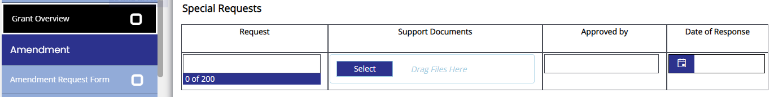

Figure 3. Upload matching funds documentation under Grant Overview

All projects funded in whole or in part through TxCDBG funds must comply with federal, state, and program requirements. Except as otherwise indicated, the procedures and requirements of the TxCDBG Project Implementation Manual apply to all work described in the TxCDBG grant agreement Performance Statement in Exhibit A, including work performed by or funded in part through other state or federal agencies.

If a construction agreement includes both a TxCDBG project and a separate project not included in the Performance Statement nor claimed as matching funds to be paid by the Grant Recipient or another funding source, the construction agreement and bid schedule should clearly indicate the work and the costs associated with each project.

2.4 Payment Request Procedures

2.4.1 Submitting a Payment Request

In TDA-GO, Navigate to Related Document tab and select Initiate Related Document.
- In the popup window that appears, ensure that the correct Parent (Grant) Number is selected., In the Available Documents field, select Payment Request and select the Create button.

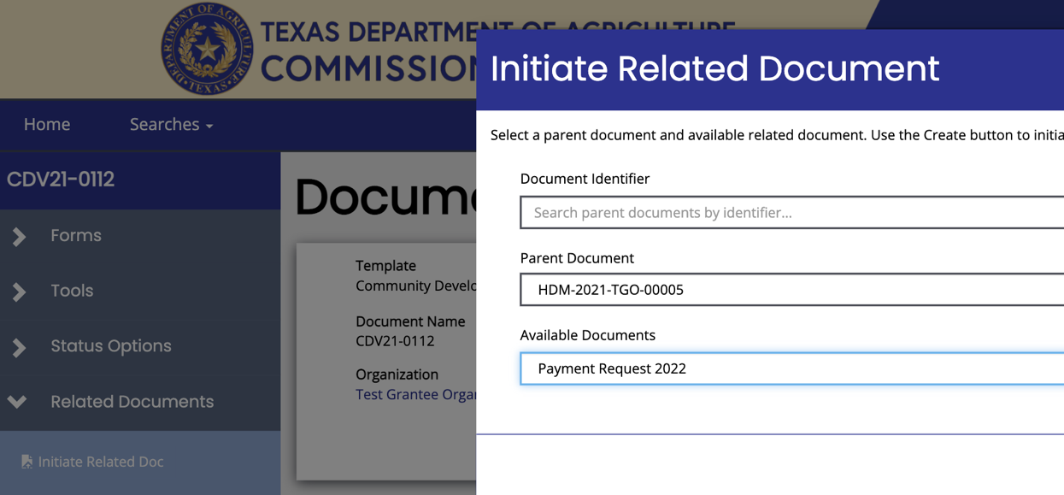
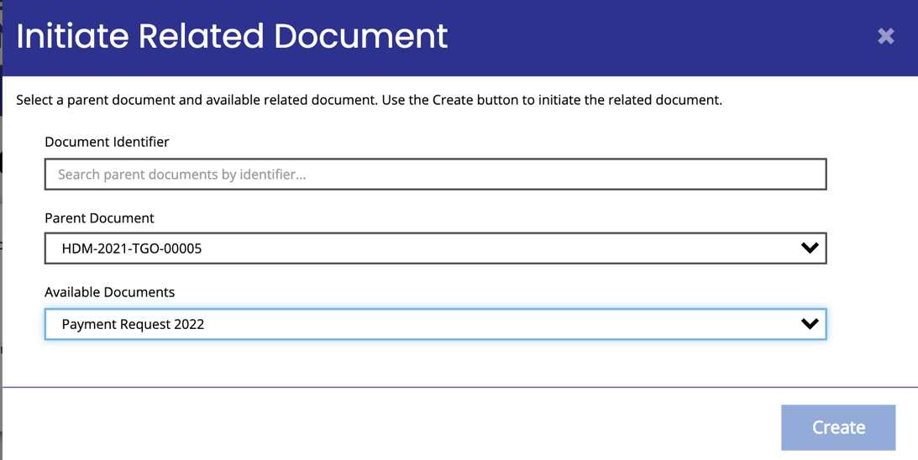

Figure 4. Initiate a related document to submit a Payment Request

- Review the CDBG Payment Request Summary page to confirm the balance available for each detailed budget row.
- TDA staff may separate an activity budget into two or more separate rows in this table to more accurately document the funds allocated to the project and the appropriate financial codes.
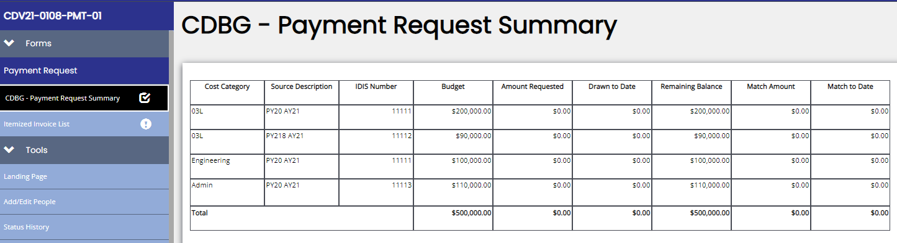
- TDA staff may revise this budget summary table to edit fund sources for the detailed budget row without requiring action by the Grant Recipient. Revisions to the total grant funds assigned to each activity budget require a grant amendment, see Chapter 11.

Figure 5. Payment Request Summary

- Select Itemized Invoice List tab in left navigation and begin entering information for the payment request.

- Complete the following payment request details:
- Service Period – Enter the earliest and latest dates covered by the invoices included in this payment request.
- RTI – Leave this field blank.
- Final Payment – Select YES only if the balance for all detailed budget rows is $0.00, or if the Grant Recipient intends to deobligate the balances remaining. The final decision on deobligation of funds will be made during the closeout process, but this response on the payment request helps TDA provide technical assistance and make funding decisions.
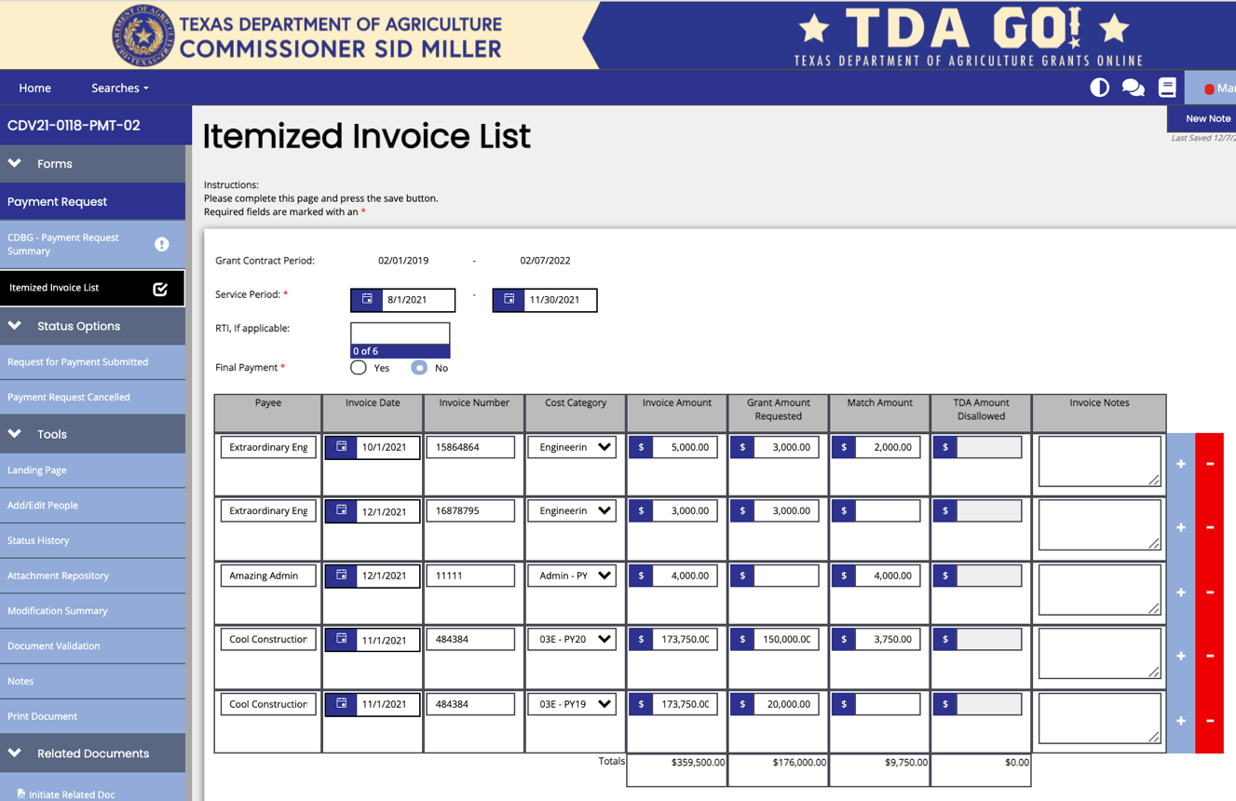

Figure 6. Example of an Itemized Invoice List

- Enter each invoice to be included in the payment request. Create a new row by selecting +.
EXAMPLE: Create one row for the invoice for the month of March administrative services, a second row for the March invoice for the engineering firm, and a third row for the April invoice for the engineering firm. Do NOT subtotal invoices even if for the same payee, unless directed to do so.
- Select the appropriate cost category for each invoice based on the detailed budget row. The cost category is a combination of the HUD Activity Code identified in the application and grant agreement and additional detail to identify the funding source for payment.
If an invoice includes costs under more than one cost category, create separate rows for each category. EXAMPLE: If a construction invoice includes costs for Activity 03J Water/Sewer and Activity 14A Rehab Utility Connection, create two rows—the grant amount requested and match amount fields for the row where the 03J cost category is selected must only include 03J costs, while the row with 14A selected must include the 14A costs only in these two fields.
- Upload invoices or similar backup documentation to support each row listed. Be sure not to use the same label. EXAMPLE: Construction 1, Construction 2, Engineering 1, Engineering 2.
- Select the Save button in the upper right corner of page, then
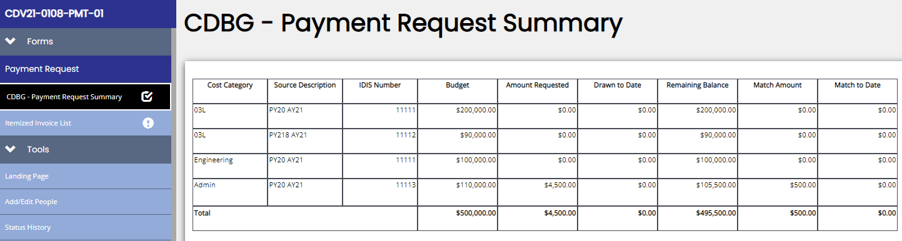
- Select the CDBG Payment Request Summary tab. Verify that balances appear as expected.
Figure 7. CDBG Payment Request Summary

- Backup documentation that justifies payment for each activity budget from which TxCDBG funds are requested, including matching funds, must be uploaded to TDA-GO. See Backup for Eligible Costs Form (Form A207) for acceptable documentation.
- All costs must be supported by invoices or similar documentation, which include information regarding the vendor, Grant Recipient, grant agreement number, invoice date, invoice number, service delivery dates (from and from), quantity, price, percentage complete (if applicable), detailed description of goods or services, previously invoiced amount (if applicable), and current amount due. See 2 CFR § 200.302(b) (3). See Chapter 8 for additional information on acceptable backup documentation for force account costs.
- Backup documentation included with a payment request must include enough information to confirm that an item is eligible under the TxCDBG grant agreement and that the work billed has been completed.
- Invoices that include costs related to two or more activity budgets, including match, the invoice must clearly indicate how the costs were allocated to the appropriate activity budgets. EXAMPLE: For an invoice that includes both Activity 03J and Activity 14A work, the Grant Recipient might mark with highlighter the specific construction line items that are assigned to the 14A activity budget.

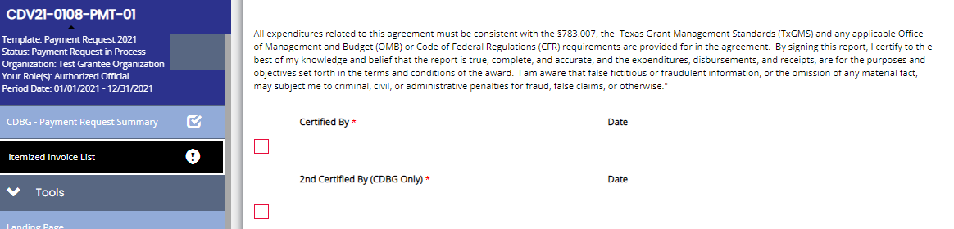
Select the Itemized Invoice List tab and secure two certifications from individuals designated as payment processors
Figure 8. Two certified signatures required

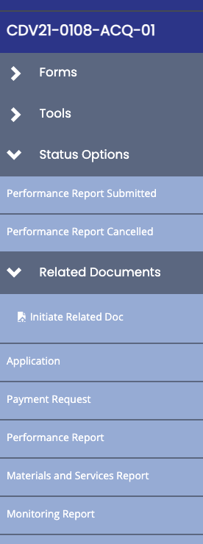
- Navigate to Status Options in left navigation and select Submit Payment Request. TDA staff will review the payment request promptly.

If TDA staff identifies minor revisions to the data, staff may make certain adjustments and note those changes in the TDA Comments box. EXAMPLE: The payment request exceeds a funding threshold that has not been satisfied, but the costs are otherwise eligible, the Grant Specialist will reduce the grant amount requested and note the amount which may be claimed on subsequent payments. If costs included on the reported invoice are not eligible for the TxCDBG program, TDA staff will indicate by noting the disallowed amount in the appropriate column and reducing the grant amount requested.

Under no circumstances will any TDA staff member increase the amount of grant funds requested on behalf of the Grant Recipient. If additional costs can be claimed, TDA staff may return the payment request to be revised and recertified by the Grant Recipient.

Once a payment request has been submitted, the Grant Recipient may check the status of the request in TDA-GO by navigating to the same payment request. The document landing page will include the current status of the request.

Figure 9. Payment Request

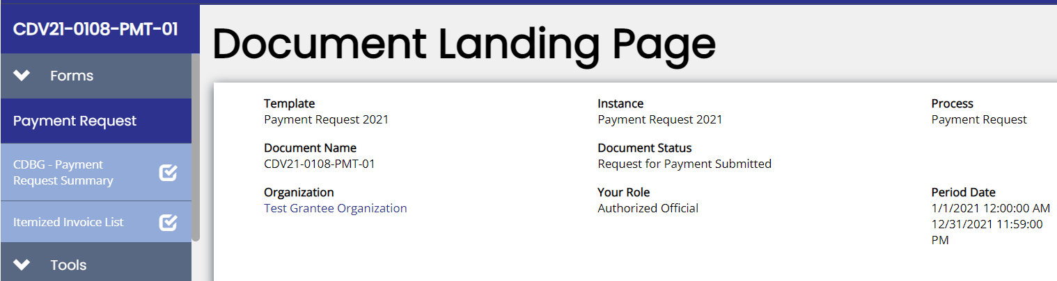
Figure 10. Payment Request submitted

If TDA staff needs additional information or is unable to proceed, the payment processor or administrative consultant will be contacted within 10 business days of the payment request submittal.

2.4.2 Minimum Payment Request Amounts and Disbursement

Grant Recipients may request reimbursement for eligible costs as often as needed, with the provision that the minimum request is $2,500. The exceptions to the minimum payment request of $2,500 rule are as follows:
- The request exceeds 25% of an activity budget and the Grant Recipient is requesting funds only for that line item;
- The Grant Recipient is requesting funds for the final retainage of a construction agreement;
- The Grant Recipient has received prior approval from TDA; or
- The request is the final request for one or more activity budgets.

Standards for Payment Requests and Disbursement of Grant Funds:
- Grant Recipients must base their payment request on actual costs incurred;
- Grant Recipient must disburse funds as soon as administratively feasible, and a maximum of five business days—not including state and federal holidays—from the time of receipt/deposit of funds to the time of actual local disbursement; for state and federal holidays, the Grant Recipient should note such holidays on their ledger to assist in determining compliance with this requirement; and
- Grant Recipients must request funds under each budget activity at least once a year or as directed by TDA.

2.4.3 Delays, Ineligible Costs, and Denial of Payment

Invoices and documentation that do not meet the minimum requirements established in this chapter will be declined.

All payment requests require certification by two payment processors—the TDA-GO system will not allow a request to be submitted without a certification. Likewise, TDA staff will decline requests that do not include the second signature required by the CDBG program.
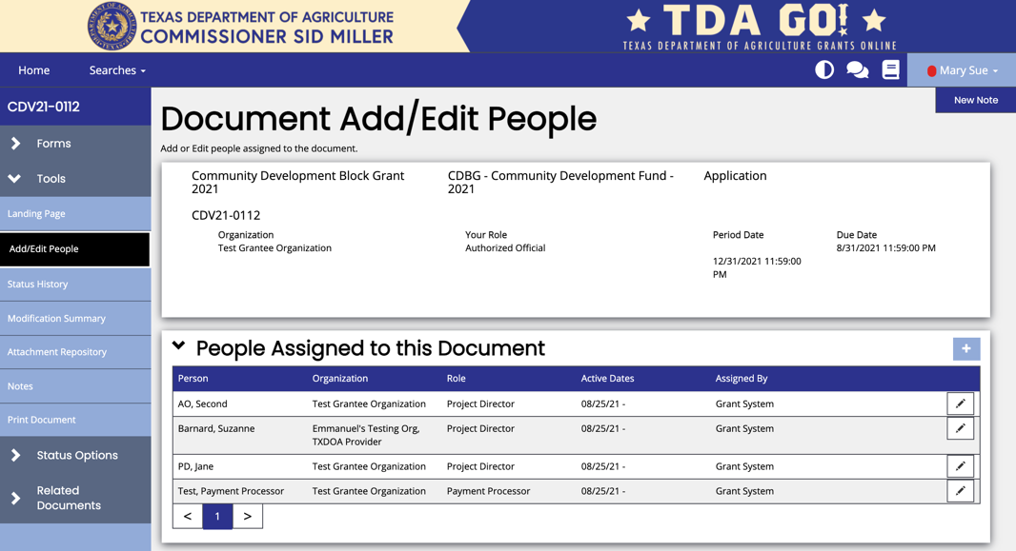

Figure 11. Add and Edit People

If some or all costs are not eligible, or are not adequately supported with backup documentation, or if the Grant Recipient is out of compliance with one or more program requirements, TDA staff will either place the payment request on hold, pending resolution of the issue, or decline the payment request. The Grant Recipient will be notified of the reasons for holding or denying requests.

If the Grant Recipient is not able to resolve the identified deficiencies within five business days, the payment request will be declined. The request may be re-submitted once the deficiencies have been resolved. Refer to Acceptable Back-up Documentation for Eligible Costs (Form A207).

Ineligible Costs
The program overview of this implementation manual includes information on the statutory eligibility of certain project costs, and application guides contain eligibility information specific to the funding opportunity. In addition, the following list includes common items that will not be approved for grant or match funding. This list is not exhaustive and project-specific costs must be considered on a case-by-case basis. Please contact TDA staff with any questions.
- Water meters for homes with no identified TxCDBG beneficiaries, including vacant homes, homes not connected to the TxCDBG-funded infrastructure, and other homes not approved as beneficiaries in the application and grant agreement.
- Commercial water meters.
- Operating and maintenance expenses of public facilities, improvements and services are ineligible for TxCDBG funding.
- Inflow and infiltration identification methods (smoke testing, televised inspection), and line cleaning (vacuuming, jetting, etc.) when used to identify general project locations.
If these methods are used to identify specific sections of wastewater line that require maintenance to reduce or eliminate the amount of inflow or infiltration routed to the treatment facilities, they are considered maintenance activities. The process of identifying target areas for wastewater line replacement must be completed prior to the submission of an application for the scope of the project to be fully identified and to expedite construction completion.
- Costs for televised inspection and similar methods are considered eligible if used for pre-construction testing on a specific reach of line (manhole-to-manhole) and/or inspection of newly constructed lines to verify proper installation.
- Software is generally ineligible unless it is integral to the function of an improvement and not utilized for billing or other operation and maintenance (O&M) purpose.
  - Software required for the operation of a supervisory control and data acquisition Software for Supervisory Control and Data Acquisition (SCADA) system is eligible.
  - If software is used for both functional and O&M billing purposes, up to 50% of the software costs may be considered eligible.
- Generators that are not permanently installed; trailer mounted generators are not considered permanently installed.
- Cost of obtaining permits or other documentation that would be required regardless of the current projects, including Certificates of Convenience and Necessity (CCN) applications, renewal of Texas Commission of Environmental Quality (TCEQ) permits, etc.
- Commercial advertising and public relations costs such as the replacement or addition of a logo, water system name, or other cosmetic painting on TxCDBG-funded water tanks and other structures.
- Costs associated with professional administration where the administrator had not been certified by TDA as required by 4 TAC § 30.80.
- Cost or fees charged for the preparation of a TxCDBG application; and
- Other similar costs.

Refer to 2 CFR Part 200 Subpart E: Cost principles for the basic guidelines of eligible costs. If the Grant Recipient will be incurring any special or unusual costs, the Grant Recipient shall seek prior written approval from TDA. See 2 CFR § 200.407.

2.4.4 Payment Revisions

If a Grant Recipient requests funds from an incorrect activity budget, a revision must be submitted as soon as the error is identified by initiating a new payment request in TDA-GO.
- Create two rows for each incorrectly reported invoice and enter the invoice information.
  - In the grant amount requested and match amount fields, enter the amount to be changed—enter a negative number to reduce the expenditures for a specific detailed budget row, and a positive number to increase the expenditures reported for the detailed budget row. The total amount of the payment request should equal $0.00.
- Upload the original invoice(s) with a clear explanation of the error and correction.
- TDA recommends a screenshot showing how the rows achieved the $0.00 balance.

Please note that a payment revision is not routine. A practice of expending funds not in agreement with the purpose for which they were requested demonstrates insufficient capacity to manage and implement TxCDBG funded projects and may result in disallowed costs and/or ineligibility for program funding. Failure to submit this revision as soon as the error becomes known during the grant agreement period may also result in costs being disallowed. Please contact your Grant Specialist with any questions.

2.5 Program Income

Program income is defined as gross income received by the Grant Recipient that was generated from activities funded in whole or in part by the TxCDBG grant agreement. As program income generated from a TxCDBG federally funded project, it is subject to all federal requirements. If a Grant Recipient earns program income, contact TDA. See 2 CFR §200.307 and 24 CFR § 570.489 for additional regulations.

The TxCDBG program is required to receipt program income payments—including general program income returned to the TxCDBG program, general program income retained by the unit of general local government (UGLG), revolving fund, and state revolving fund payments—in HUD’s Integrated Disbursement and Information System (IDIS) on an annual basis. As a nationwide database, IDIS provides HUD with current information regarding the program activities underway across the nation, including funding data.

Total program income under $35,000 received by Grant Recipients in a single year from activities, other than revolving loan funds that are retained by a Grant Recipient, do not have to be reported as program income and would not be receipted in IDIS. All funds received from revolving loan funds are considered program income regardless of amount. Once the annual total equals or exceeds $35,000, the entirety is to be reported.

An exemption in the definition of program income is when renting property; program income is the gross income less any costs incidental to the generation of that income. EXAMPLE: If renting a community center for events, the portion of the rental payments used for maintenance and staff would be incidental to the operations, and therefore would not be considered program income.

Grant Recipients that generate program income must contact TDA for directions on reporting and returning program income to the State.

2.6 Investigation of Fraud Allegations

Allegations of fraud may be reported to TDA or to the HUD Office of the Inspector General. The report must include a written statement in support of the alleged fraud, waste, abuse, and/or mismanagement. Allegations of fraud involving any TxCDBG funds will be investigated immediately after being brought to the attention of TDA, through whatever source.

Contact information to report FRAUD or WASTE in HUD-funded programs and operations:
HUD Inspector General Hotline
451 Seventh Street, SW
Washington, D.C. 20410
HUD-OIG Hotline toll-free 800-347-3735 | FAX: 202-708-4829
See Appendix A for email and website information

An investigation will be conducted if the allegations are made in connection with the services provided by a Grant Recipient using TxCDBG funds. TDA will immediately:
- Notify the Grant Recipient of the allegation and advise that TDA will investigate; or
- Advise the Grant Recipient that it must conduct a preliminary investigation and submit a written report within seven working days from the date of notification. The report must include
  - the nature of the allegation, dollar amount involved, whether a fidelity bond exists and its dollar coverage;
  - who is involved, i.e., individual(s) accused of fraud, Grant Recipient's name, names of the Grant Recipient's council/commission, and the Grant Recipient's chief elected officer;
  - when the allegations were made;
  - time period involved;
  - where the incident occurred; and
  - how the alleged incident occurred.

The TxCDBG compliance staff will review the report and decide whether further investigation is warranted.
- If further investigation is not warranted, the file is closed, or the Grant Recipient is directed to conclude the issue administratively.
- If it is determined that further investigation is warranted, TDA will conduct a full investigation of the allegations and may recommend withholding payments to the Grant Recipient, pending completion of the investigation. The scope of the investigation will be determined by the facts surrounding the incident.

Upon completion of the investigation, if applicable, TDA will:
- Prepare an incident report that includes all findings and any initial corrective action taken to date by TDA;
- Prepare a plan for corrective action, debt collection, and a plan for prosecution, if applicable;
- Request a claim against the fidelity bond to be filed, if applicable;
- Proceed with the resolution process on any costs which are questioned as a result of the investigation;
- Conduct a follow-up visit to ensure that corrective action has been implemented; and
- Initiate debt collection procedures with the Grant Recipient, as applicable.

