CHAPTER 12
GRANT AGREEMENT CLOSEOUT

TABLE OF CONTENTS

Page

12.0 Introduction 2
12.1 Final Public Hearing 2
12.2 Project Completion Report (PCR) 3
12.2.1 Confirmation of Final Project Details 3
12.2.2 Conditional Project Completion 6
12.2.3 Section 3 8
12.2.4 Direct Beneficiaries 8
12.3 Submitting the Report 10
12.4 Grant Closeout 11

CHAPTER 12
GRANT AGREEMENT CLOSEOUT

12.0 Introduction

The TxCDBG grant closeout process is designed to ensure that all CDBG activities are completed and funds are expended in accordance with the grant agreement, program rules, and state and federal requirements. This means that any financial, administrative, and performance issues related to the activities undertaken by the Grant Recipient have been resolved to the satisfaction of TDA and the Grant Recipient. The closeout process also certifies that the persons to benefit from the activities described in the grant agreement Performance Statement are receiving service or a benefit from the use of the new or improved facilities and activities.

The closeout process should begin when
- all Performance Reports are in Performance Report Approved or Performance Report Submitted status;
- all Materials and Services Reports are in MSR Contract Complete or MSR Contract Completion Submitted status;
- all grant agreement special condition documents have been uploaded to the Grant Overview page;
- all costs to be paid with TxCDBG funds have been expended and payment requests submitted, with the most recent Payment Request marked as “Final”;
- the activities described in the most recently approved grant agreement Performance Statement has been completed; and
- the Grant Recipient’s other responsibilities under its agreement with TDA have been met.

12.1 Final Public Hearing

Grant Recipients shall hold a public hearing for residents of the areas in which TxCDBG funds were used and encourage citizen participation. The TxCDBG grant agreement and 24 CFR § 570.486 require a final public hearing regarding the activities completed under the TxCDBG grant.

See Chapter 1 Administration and Reporting Section 1.1.5 for detailed instructions regarding public hearings, notices, and documentation.

In addition to the general public hearing requirements
- the hearing must be scheduled after the project is completed but prior to submitting the Project Completion Report in TDA-GO; and
- the Grant Recipient must confirm during the hearing that beneficiaries are being served by the project, except as provided in Section 12.2.5 of this chapter.

12.2 Project Completion Report (PCR)

After all grant activities are complete, but no later than sixty calendar days after the grant agreement end date, begin the closeout process by changing the status of the grant in TDA-GO to Closeout In Process status. The CDBG Project Completion Report (PCR) page will become available to be completed.

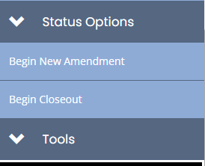
Figure 1. Begin Closeout status option

12.2.1 Confirmation of Final Project Details

The Confirmation of Final Project Details section of the PCR page contains several reports summarizing information provided by the Grant Recipient over the course of the grant.
- Generate each report by clicking the link on each row. Review the report and check the box on the same row to confirm that the report is accurate and complete.
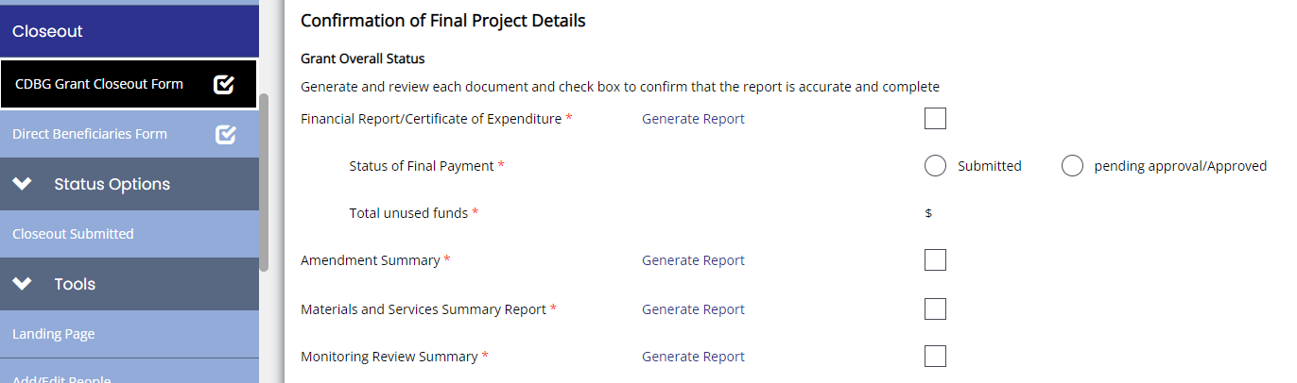
- If the summary reports are not complete and accurate, navigate to the appropriate forms or related documents to update the information. In most cases, the closeout process must be cancelled in order complete the updates. If the closeout process is cancelled due to inaccuracies discovered after the closeout is submitted for TDA review, the Grant Recipient will not be credited for the original submittal date and the delinquent PCR penalty outlines in section 12.4 of this chapter will apply.
Figure 2. Generate each report to verify completeness and accuracy reports

Financial Report/Certificate of Expenditure
- Review the expenditure and grant balance information carefully. Check the box to confirm all information is accurate.
- Indicate the status of the final Payment Request. Once the closeout process is started in TDA-GO, no further Payment Requests can be submitted within the system.
  - At a minimum, the final Payment Request must be submitted prior to beginning the Project Completion Report.
  - Final administration costs not claimed on the final Payment Request will not be eligible for reimbursement.
  - With prior approval, the Grant Recipient may request to reserve funds for certain outstanding costs by submitting a Payment Request for estimated costs that does not yet include the required invoice documenting actual costs. Approval for use of this option must include a statement by the TxCDBG Director in the Notes page of the Payment Request. The limited circumstances for reserved funds include
    - costs of producing a single audit for the fiscal year in which the closeout is due;
    - costs associated with litigation;
    - other costs approved in advance by TDA staff and documented on the Grant Overview page in TDA-GO.
- All match funds or in-kind contributions must be identified on a Payment Request. The ratio of actual match funds to grant funds requested for payment must meet or exceed the percentage match commitment in the grant agreement.
- No more than 16% of the combined TxCDBG grant funds expended for construction and acquisition/relocation activities may be expended for administrative costs. No more than 25% of the combined TxCDBG grant funds expended for construction and acquisition/relocation activities may be expended for engineering costs apart from exceptional cases. If the Grant Recipient deobligates funds from the grant during the closeout process, the administrative costs and the engineering costs charged to the grant will be reevaluated to ensure that final costs are within 16% administrative costs or 25% engineering costs of the actual construction and acquisition/relocation grant funds utilized. For more information, include circumstances where a waiver to this policy may be considered, see Chapter 2.
- All funds not included in a Payment Request submitted prior to the closeout process will be deobligated from the grant agreement and will not be available for reimbursement. The Grant Recipient must acknowledge the total amount of deobligated funds by entering this amount in the appropriate field.
NOTE: If additional deobligated funds are identified as a result of disallowed costs or ineligible requests, TDA staff will revise this field and include documentation of the amount and justification.

Grant Performance
The Grant Recipient must confirm that the current grant agreement Performance Statement is accurate by checking the box in the Grant Performance section of the PCR.

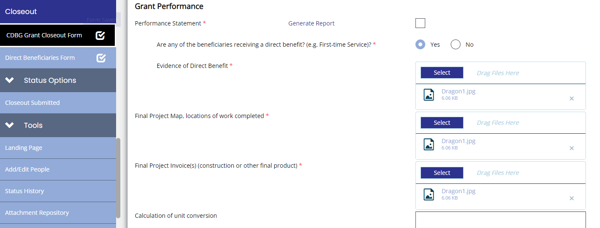

Figure 3. Generate each report to verify completeness and accuracy reports

- Direct Household Beneficiaries - If the grant includes work on private property funded through grant or match funds, including water and sewer service connections, the Grant Recipient must mark the relevant question in the affirmative and attach evidence that the households occupying those properties are in fact receiving a benefit:
- List the name, address, number of beneficiaries, and income level of each household;
- Documentation that beneficiaries are receiving services for such projects, such as:
- Copies of utility bills for all beneficiary households;
- Printout of accounts from utility billing system;
- Letter from the utility provider signed by the managing authority certifying an attached list of account holders and households are receiving services; or
- Other reasonable documentation approved by TDA.
- Direct Job Creation Beneficiaries – if the grant includes job creation activities, mark direct beneficiaries as “yes” and upload as Evidence of Benefit a list of all employees identified on the final payroll and claimed as jobs created or retained as a result of the grant. This list must include for each employee:
  - Name;
  - Full time or part time status as described in Section D; and
  - LMI status.
- Final Project Map – Upload a map clearly documenting the work performed under the grant. This map must identify the exact locations of all project improvements and must be consistent with the grant agreement Performance Statement. Do not include work planned or designed but not actually constructed or performed. Maps from the application or the design phase of the project will not be accepted.
NOTE: For planning grants, upload the cover page of the final planning document in the field. For FAST Fund purchases, upload a photo(s) of the purchased vehicle or equipment.
- Final Project Invoice(s) – Upload the final invoice for each construction (or other primary activity) contract. The invoice(s) must demonstrate the actual work performed and quantities completed and must be consistent with the work and quantities identified in the grant agreement Performance Statement (generally within 15% variance or less).
- Calculation of Unit Conversion – If construction contract units of measure differ from the units used in the grant agreement, provide the method used to convert constructed quantities to the units required by the Performance Statement. For example, provide a formula or narrative explanation to demonstrate that the square yards documented in the construction contract are equivalent to the linear feet of improvements required by the Performance Statement. An engineer’s statement may also be uploaded to the PCR to provide relevant information, as needed.
- Publication and Evidence of Final Public Hearing – See Chapter 1 Administration and Reporting Section 1.1.5 for detailed explanation of documentation required for public hearings.
- Additional Documentation – This field is optional and may be used for any additional information required to document closeout of the grant.
  - TDA recommends attaching before and after photos for each project.
  - Additional rows may be added by clicking the “+” button.

12.2.2 Conditional Project Completion
The closeout process confirms that the beneficiaries of the project are actually receiving the service or a benefit from the improvements required by the grant agreement to satisfy the National Program Objective. There are some circumstances where TDA may allow the closeout process to begin prior to the Grant Recipient’s final certification that this benefit has been received. In such a case, the Grant Recipient must contact the TxCDBG Director(s) to request approval prior to submitting the Project Completion Report.

Conditional Completion of Projects that Require Regulatory Approval
Regulatory approval required by other state and federal agencies prior to placing the improvements into service should be obtained prior to considering the project complete. For example, a Texas Commission on Environmental Quality (TCEQ) interim approval for a new well must be issued before the well can be placed into service and the beneficiaries are able to benefit from the project. Reverse osmosis systems, arsenic removal improvements, and other innovative technology have similar requirements for TCEQ approval.

Grant Recipients are strongly encouraged to ensure that all project approvals are received prior to certifying the project completion. However, TDA will accept closeout documentation prior to receipt of such an approval under certain conditions:
- Complete documentation required to request approval for the project must be submitted to the regulatory agency prior to the submission of the PCR, including all required testing or supporting data.
- The public hearing notice must disclose that the project has not been approved for use by the regulatory agency.
- The Grant Recipient must check the box on the PCR to “request TDA acceptance of the project as Conditionally Complete.” After providing information for all required fields, send an email to CDBGReporting@TexasAgriculture.gov to request Director approval. The PCR cannot be submitted within TDA-GO while Conditional Completion has been requested but not approved.
- If the Project Approval is Granted by the Regulatory Agency – TDA will proceed with the closeout process; no costs will be disallowed based on the additional time for approval and no additional public hearing will be required.
- If the Project is Not Approved for Use – TDA will decline the PCR if the regulatory agency does not approve the project based on the information submitted prior to the PCR due date. This means that if any substantial revision or re-testing is required after the closeout documents are submitted to TDA, the PCR will be considered delinquent, generally resulting in the loss of final administrative funds. The closeout process must be restarted in TDA-GO, including a new public hearing once the project received the required regulatory approval.

Other Conditional Completion of Projects
TDA may accept closeout documentation prior to final certification of the National Program Objective under limited circumstances other than regulatory approval. The Grant Recipient may submit a written request to CDBGReporting@TexasAgriculture.gov for TxCDBG Director approval under the following conditions:
- The TxCDBG grant is part of a project funded through multiple funding agencies, and the TxCDBG-funded activities are complete while related activities are not yet complete;
- The TxCDBG grant is involved in litigation or other disputes regarding workmanship; or
- Other circumstances approved in writing by TxCDBG staff.

Final Acceptance of National Program Objective
After a review of all other PCR information, TDA staff will change the status of the conditionally complete grant to Closeout Revisions Required while the documented issue is pending.

Once the pending issues are resolved, the Grant Recipient must immediately complete the remaining fields in this section of the PCR:
- Upload documentation of the resolution, including regulatory agency approval received, litigation settlement, etc.; and
- Enter the date the resolution was effective.
- Change the status of the grant to Closeout Submitted to resume the closeout process.

The grant will not be considered administratively complete until the pending issues are resolved with documentation submitted to TDA, and the benefit is confirmed.

The Grant Recipient may be permitted to submit a new application for funding that is subject to the Progress Threshold #2 while the grant is conditionally complete; however, a grant agreement for new TxCDBG funding will not be issued until the benefit is confirmed through the above documentation. Refer to the applicable Request for Applications/Application Guide for information regarding Progress Threshold #2.

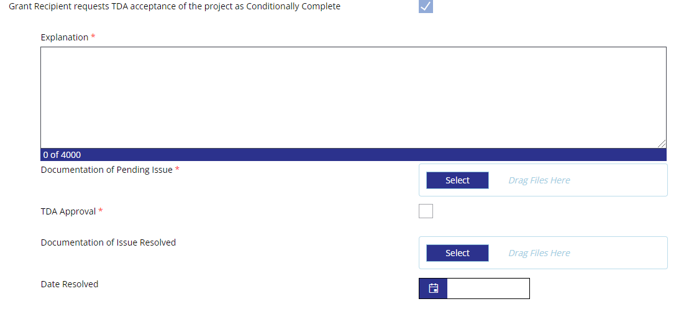

Figure 4. Upload supporting documents to prove that the grant is administratively complete

12.2.3 Section 3
The closeout process includes a final section on Section 3 opportunities. See Chapter 10, Section 10.1.8 for details on this program reporting requirement.
- Reportable labor hours entered on each Materials and Services Report, Work Completed page, are summarized in the Materials and Services Summary Report and must be confirmed in the Confirmation of Final Project Details section of the PCR.
- Separately, confirm whether the grant created one or more new employment opportunities. These opportunities may be new jobs created by the Grant Recipient or its contractor to complete the project or may be vacancies in existing jobs that were filled in order to complete the project. If yes, include the number of new opportunities and success in recruiting Section 3 workers in the Other Efforts explanation field below.
- Document the Grant Recipient’s efforts to promote Section 3 opportunities. Check the box for each qualitative effort that apply to the project or describe other efforts.

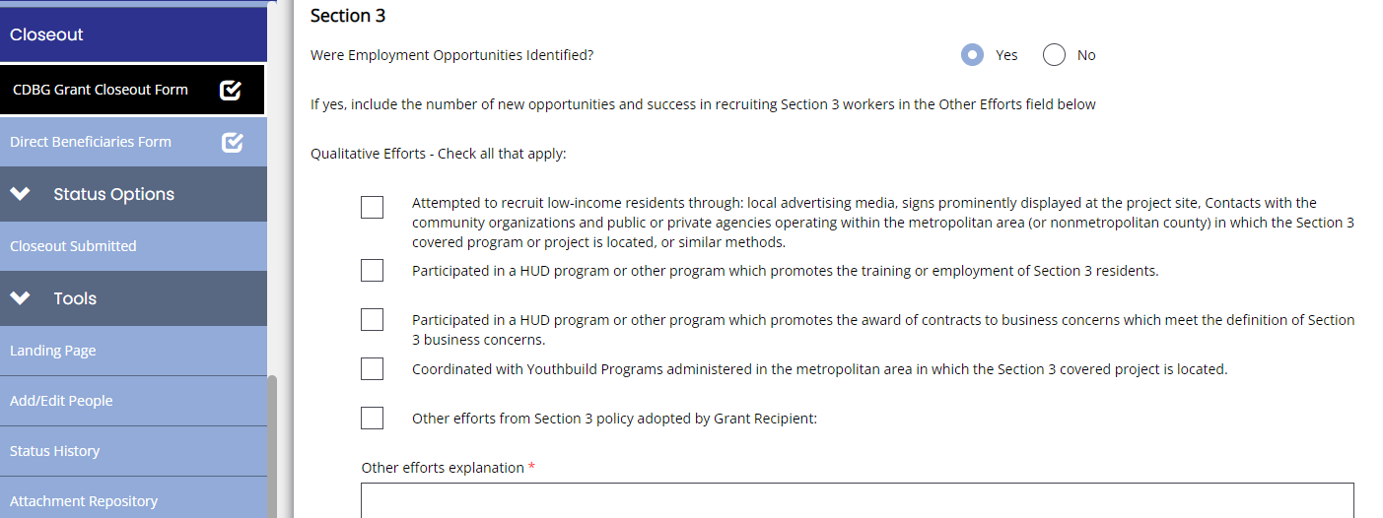

Figure 5. Check all boxes that apply to your Section 3 opportunities

12.2.4 Direct Beneficiaries

If the Grant Recipient indicated on the PCR that the project included direct benefit, the Direct Beneficiaries Form will become available as a separate page. Provide demographic information for the total number of persons receiving direct household or job creation benefit from the project. This information must be reported to HUD.
- Report the total number of individual beneficiaries, and the total number of households identified for direct benefit activities (14A and 014 Housing Rehabilitation Benefit Areas, 18A job creation Benefit Areas).
- Beneficiaries of area wide activities, such 03J Water/Sewer Improvements or 03K Street Improvements, are not considered direct household beneficiaries and should not be included on the Direct Beneficiaries page.
- Count each individual direct beneficiary only once, even if the grant includes several Benefit Areas for the household. For example, if a household benefits from both utility connections (14A) and substantial housing rehabilitation (014), count the individuals in that household only once.
- Ensure that the same total number of persons are reported for income level, gender, ethnicity, and race demographics.

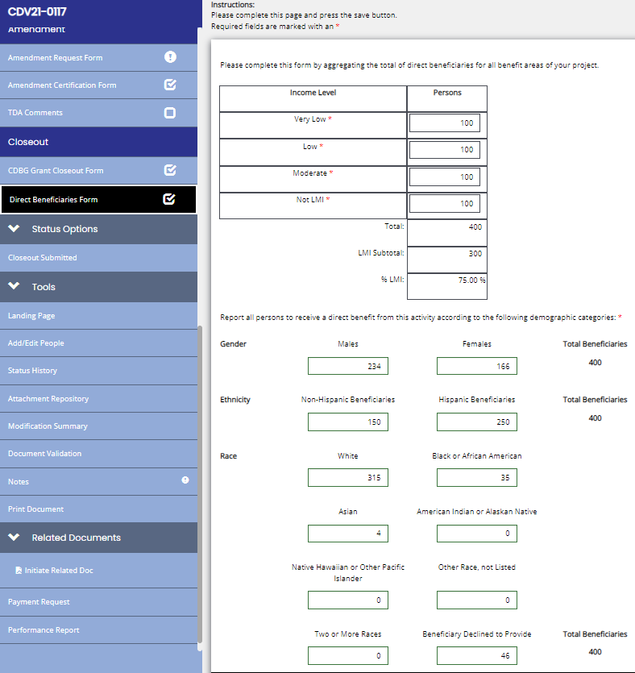
Figure 6. Provide demographic information for the total number of persons receiving direct household or job creation benefit from the project

For projects providing housing rehabilitation/reconstruction, an additional section will become available based on an affirmative response. See Section C Housing Rehabilitation for detailed instructions.

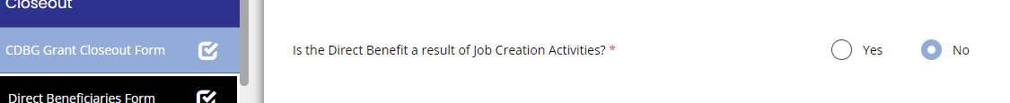
For projects creating or retaining jobs, an additional section will become available based on an affirmative response. See Section D Economic Development for detailed instructions.

Figure 7. Continue to fill out the CDBG Grant Closeout Form

12.3 Submitting the Report

When all closeout information and documentation has been completed on the PCR, the Authorized Official must certify that the PCR is accurate and complete.
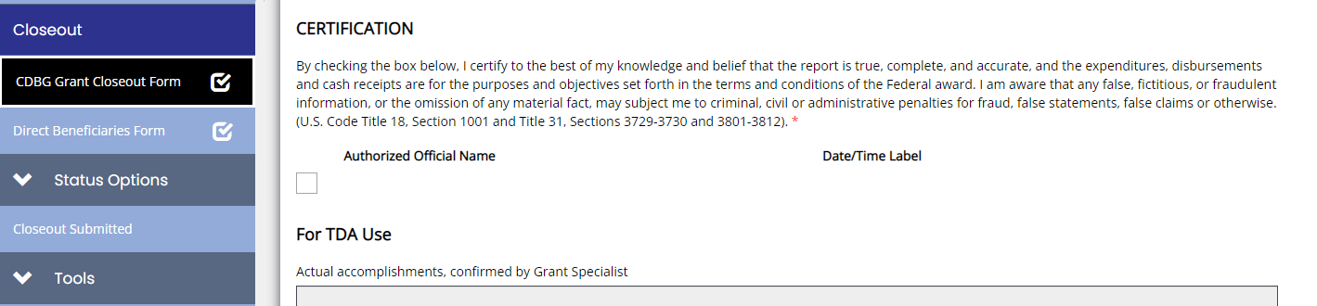
- The Authorized Official must check the certification box on the Project Completion Report page and click Save.
Figure 8. The Authorized Official must check the certification box

By certifying the Project Completion Report, the Authorized Official is certifying that
- all activities undertaken with funds provided under the grant identified in this report, have, to the best of their knowledge, been carried out in accordance with the grant agreement;
- the information contained in the PCR is accurate to the best of their knowledge;
- all records related to Grant Recipient activities are available for review;
- TxCDBG funds were not used to reduce the level of local financial support for housing and community development activities;
- no attempt to recover any capital costs of public improvements assisted in whole or in part with such funds by assessing any amount against properties owned and occupied by persons of low and moderate income, including any fee charged or assessment made as a condition of obtaining access to such public improvements unless (a) such funds are used to pay the proportion of such fee or assessment that related to the capital costs of such public improvements that are financed from revenue sources other than such funds; or (b) for purposes of assessing any amount against properties owned and occupied by persons of moderate income, Grant Recipient certifies that it lacks sufficient funds under this grant to comply with the requirements of clause (a);
- the persons benefitting from the activities described in Grant Agreement Details – Performance Statement, of this grant agreement are receiving service or a benefit from the use of the new or improved facilities and activities;
- proper provision has been made for the payment of all unpaid costs and unsettled third-party claims and the state of Texas is under no obligation to make any further payment to the recipient under the grant agreement in excess of the amount identified in the Certificate of Expenditures table as TxCDBG Reserved Funds; and
- the expenditures, disbursements and cash receipts are for the purposes and objectives set forth in the terms and conditions of the federal award. They are aware that any false, fictitious, or fraudulent information, or the omission of any material fact, may subject them to criminal, civil or administrative penalties for fraud, false statements, false claims or otherwise. See U.S. Code Title 18, Section 1001 and Title 31, Sections 3729-3730 and 3801-3812.

After the Authorized Official certifies the PCR, navigate to the Status Options section on the left navigation menu and select Submit Closeout. Once grant status is changed to Closeout Submitted, TxCDBG staff will review the report for accuracy and completeness.
- Incomplete reports will not be accepted and TDA staff will return the status of the grant to Closeout In Process. This means that the PCR will not be submitted and will be considered delinquent if the closeout due date has passed. The PCR must be corrected and submitted in TDA-GO.
- PCRs that include serious deficiencies or information that does not reflect the Performance Statement and/or Budget will not be accepted and will be returned to Closeout In Process status.
- For minor deficiencies and corrections, TDA staff will change the status of the grant to Closeout Revisions Required, which will allow the Grant Recipient to correct the deficiencies. Required revisions will be identified in the Grant Specialist Notes field at the bottom of the PCR page; if more detailed instruction is required, TDA staff will create an entry in the Notes page of the grant document. Once corrected, within fifteen days of the deficiency notice, change the status of the grant to Closeouts Submitted to continue the closeout review process.

Closeouts Due Date
The grant status must be changed to Closeout Submitted status no later than sixty days after the grant agreement end date in order to comply with the terms of the agreement. The closeout due date is identified in the grant agreement and in the Basic Grant Information section of the PCR.

Late submittal of a PCR may affect a Grant Recipient’s current or future TxCDBG funding.
- Failure to submit the closeout by that date will result in a financial penalty of $3,000, generally assessed against the administration line item in Exhibit B Budget of the grant agreement.
- Requests for payment on all open grants for the Grant Recipient may be held until an acceptable PCR is received.
- New awards may be placed on hold until an acceptable PCR is received, and the award may be withdrawn if the delinquencies are not resolved within 90 days of the award announcement.
- Future requests for funding will be subject to scoring penalties for failure to timely submit closeout documents. Refer to the applicable Request for Applications/Application Guide for information regarding past performance scoring criteria.
- Continual unsatisfactory performance and delays in submitting closeout documents may be considered evidence of a lack of administrative capacity for future TxCDBG funding.

12.4 Grant Closeout

The grant is not considered closed until the following steps have been completed:
- The Grant Recipient submits the PCR, certifying that the project is complete and all requirements have been met.
- TDA’s TxCDBG monitoring staff completes all required monitoring reviews and changes the status to Monitoring Complete.
- TDA staff reviews all grant closeout documentation, approves all payments, and update the grant status to Grant Closed.
- The Grant Recipient must also complete an Organizational Compliance – Single Audit Report for each fiscal year from the date of award to the date the PCR was submitted.

NOTE: Grant closeout does not begin the record retention period for the grant. The beginning of the record retention period will be indicated by a change in status of the grant to Funding Year Closed. Please see Program Overview in this Manual for further information on record retention requirements.

