Texas State of Office of Rural Health

2022-2023 Small Rural Hospital Improvement Grant Program (SHIP)

Grant Information & Application Completion Instructions

Table of Contents

Information for Submitting Application | 2
Program Rules and General Information | 3
Application Completion Instructions for TDA GO! | 8

INFORMATION FOR SUBMITTING APPLICATION
The application procedures for the 2022-2023 Small Rural Hospital Improvement Grant (SHIP) are included in this Application Guide. The procedures in this application guide supersede those published in all previous SHIP application guides.

The deadline for all 2022-2023 SHIP applications is 11:59 p.m. CT on January 19, 2022. The application form in the TDA GO! grant management system must be completed and submitted by the deadline date for an applicant to be considered for funding. Instructions for completing the application in the TDA GO! system begin on Page 7.

Ensure the information provided in the TDA GO! Applicant Contact Information and Application Form is accurate and complete before submitting. Only one application per applicant/facility is allowed.

The 2022-2023 SHIP online application form can be accessed using the following link:

TDA GO! - if you are unable to get in using CHROME try pasting the URL into a different browser
such as Microsoft Edge. See Important Information section on page 7.

The application contains the guidelines for completing the grant request. Please read all materials and the application before preparing and submitting the grant application in the TDA GO! system. Applications must provide all the requested information. Please read all questions and accurately answer each as it pertains to the applicant.

Any questions regarding the 2022-2023 SHIP program, the TDA GO! application form, application information and/or Texas Department of Agriculture (TDA) requirements can be directed to the State Office of Rural Health Regional Coordinators. For immediate assistance, please call (512) 923-9000 or email RuralHealthInbox@TexasAgriculture.gov.

South Region - Eva Cruz Eva.Cruz@TexasAgriculture.gov
Panhandle Region – Ryan Horsak Ryan.Horsak@TexasAgriculture.gov
West Region - Kathy Johnston: Kathy.Johnston@TexasAgriculture.gov
East Region - Trish Rivera: Trish.Rivera@TexasAgriculture.gov
North Region - Robert Shaw: Robert.Shaw@TexasAgriculture.gov
Central/Gulf Region - Shari Wyatt: Shari.Wyatt@TexasAgriculture.gov

Failure to follow the instructions and requirements described in these guidelines may result in the disqualification of the application.

PROGRAM RULES AND GENERAL INFORMATION
This application guide contains the requirements that all applicants are required to meet to be eligible for funding. Failure to conform to these requirements may result in the disqualification of the application. Each applicant is solely responsible for the preparation and submission of the online application form in accordance with the instructions in these guidelines.

Statement of Purpose

The purpose of SHIP is to assist small rural hospitals of 49 beds or less with their quality improvement (QI) efforts and with their adaptation to changing payment systems through investments in hardware, software, and related trainings. SHIP funded investments include:
- activities that support improved data collection to facilitate quality reporting and improvement;
- activities that support the development or basic tenets of ACOs or shared savings programs; and/or
- activities that improve hospital financial processes.

Eligibility

The State Office of Rural Health (SORH) (within TDA) will be the official grantee of record and act as a fiscal intermediary for all hospitals applying for SHIP funding. Applications will be screened for eligibility and completeness. SORH will compile all eligible applications and submit one SHIP application to the U.S. Department of Health and Human Services, Health Resources and Services Administration (HRSA).

Eligible applicants are small hospitals located in a rural area. For the purpose of this program:
- “small hospitals” is defined as a non-Federal, short-term general acute care hospital that: (i) is located in a rural area as defined in 42 U.S.C. 1395ww(d) and (ii) has 49 available beds or less, as reported on the hospital’s most recently filed Medicare Cost Report;
- “located in a rural area” is defined as either: (1) located outside of a Metropolitan Statistical Area (MSA); (2) located within a rural census tract of a MSA, as determined under the Goldsmith Modification or the Rural Urban Commuting Areas (RUCAs); or (3) is being treated as if being located in a rural area pursuant to 42 U.S.C. 1395(d)(8)(E); and
- Eligible hospitals may be for-profit or not-for-profit, including faith-based. Hospitals in U.S. territories as well as tribally operated hospitals under Titles I and V of P.L. 93-638 are eligible to the extent that such hospitals meet the above criteria.

Award Amount

Awards are subject to the availability of funds. If funds are not appropriated or collected for this program, applicants will be informed accordingly. The estimated maximum budget of $12,386 should be used to support and implement eligible activities.

Eligible Uses of Grant Funds

Applicant hospitals must select activities outlined in the federally prescribed application. Eligible activities include:
- Value-Based Purchasing
- Accountable Care Organizations or Shared Savings
- Payment Bundling/PPS

Click here for: Allowable and Unallowable Activity Examples

Responsibilities and Accountability of a Grantee

The grantee has full responsibility for the conduct of the project and for the results achieved. Each grantee shall monitor the day-to-day performance of the grant project to assure adherence to statutes, regulations, and grant terms and conditions. The grantee will carry out the activities described in the scope of work to achieve project goals, objectives, and desired outcomes. The grantee will be accountable for all grant funds and must ensure all funds are used solely for authorized purposes.

The grantee must ensure:
- Funds are used only for activities covered by the approved project.
- Funds are not used in violation of the restrictions and prohibitions of applicable statutes.
- The final project completion report is submitted in a timely manner with all required
documents.

Each grantee must ensure they have an adequate accounting system in place and good internal controls to ensure expenditures and reimbursements are reported and records are maintained for a minimum of three (3) years after the conclusion of the project.

Reporting: Grantees may be required to submit periodic performance reports. Specific reporting timelines will be provided in the grant agreement. As part of TDA's ongoing monitoring of grant funds, grantees must show both a strong progress of work completed on all projects as well as financial progress. Failure to comply with reporting requirements may result in the withholding of a request for reimbursement and/or termination of the award.

Reimbursement: Grantees are encouraged to complete their SHIP project(s) and utilize all SHIP grant funds. Failure to complete the SHIP project(s) and utilize all awarded SHIP funding may jeopardize the eligibility status for applying for future SHIP funding by a grantee. Grantees will be paid on a cost reimbursement basis. Grantees are required to submit a project completion report when their project is complete reflecting the status of the project. Copies of invoices, purchase orders, proof of payment such as canceled checks, bank statements, or other supporting documentation including spreadsheets must be submitted along with the completion report before grant funds will be released. Once submitted, the project completion report shall be reviewed, approved, and grant funds will be disbursed.

General Information

TDA reserves the right to reject all applications and is not liable for costs incurred by an applicant in the development, submission, or review of the application; or costs incurred by a selected applicant prior to the effective date of grant agreement.

TDA reserves the right to alter, amend, or clarify any provisions, terms, or conditions of this program or any grant awarded as a result thereof, or to terminate this program at any time prior to the execution of an agreement, if TDA deems any such action to be in the best interest of TDA and of the State of Texas. The decision of TDA will be administratively final in this regard.

Applicants are responsible for clearly designating any portion of the application that contains proprietary or trade secret information and must state the reason(s) the information is designated as such. Merely making a blanket claim that the entire application is protected from disclosure because it contains proprietary or trade secret information is not acceptable, and shall make the entire application subject to release under the Texas Public Information Act. In the event that a public information request for the application is received, TDA shall process such request in accordance with Section 552.305 of the Texas Government Code. Applicants are advised to consult with their legal counsel regarding disclosure issues and to take appropriate precautions to safeguard trade secrets or any other proprietary information.

All applications submitted under this program are subject to release as public information, unless the application or specific parts of any such application can be shown to be exempt from disclosure under the Texas Public Information Act, Chapter 552 of the Government Code.

Conflict of Interest

Applicants are required to disclose any existing or potential conflicts of interest relative to this grant program. Failure to disclose any such relationship may result in the disqualification of an application or termination of agreement.

General Compliance Information

- Grantees must comply with TDA’s reporting requirements and financial procedures outlined in the grant agreement. Any delegation by the Grantee to a subcontractor regarding any duties and responsibilities imposed by the grant award must be approved in advance by TDA and shall not relieve the Grantee of its responsibilities to TDA for their performance.
- All grant awards are subject to the availability of federal funding, and appropriations and authorizations by the Texas Legislature.
- Grantees must remain in full compliance with state and federal laws and regulations. Non-compliance may result in termination of the grant or ineligibility for reimbursement of expenses, as applicable.
- Grantees must keep separate records and a bookkeeping account (with a complete record of all expenditures) for grant funds and activities. Records shall be maintained for a minimum of three (3) years after the completion of grant activities, or as otherwise agreed upon with TDA. If any litigation, claim, negotiation, audit or other action is initiated prior to the expiration of the three-year retention period, then all records and accounts must be retained until their destruction is authorized by TDA. The federal awarding agency, TDA, and the Texas State Auditor’s Office (SAO) reserve the right to examine all books, documents, records, and accounts relating to the grant, including all electronic records, at any time throughout the duration of the agreement until all litigation, claims, negotiations, audits or other action pertaining to the grant is resolved, or until the expiration of the three-year retention period, whichever is longer. The federal awarding agency, TDA, and the SAO shall have access to: all electronic data or records pertaining to the grant; the physical location where records are stored; and all locations related to grant activities.
- If the Grantee has a financial audit performed during the time the Grantee is receiving funds from TDA, upon request TDA shall have access to information about the audit, including the audit transmittal letter, management letter, any schedules, and the final report or result of such audit.
- Grantees must comply with Texas Government Code, Chapter 783, Uniform Grant and Contract Management; the Uniform Grant Management Standards (UGMS); 2 CFR part 200, Uniform Administrative Requirements, Cost Principles, and Audit Requirements for Federal Awards; and 45 CFR part 75, Uniform Administrative Requirements, Cost Principles, and Audit Requirements for HHS Awards, if applicable.

Welcome to TDA’s new grant management system, TDA GO!! This guide describes how to complete your 2022 SHIP application. For more detailed technical assistance information on navigating through the TDA GO! system, please view the TDA Go! Grant Recipient Training Manual This manual provides information on changing passwords or users, sending and accessing messages, document searches, etc. The link for the manual is located on the page icon in the upper righthand corner of the screen (Figure 1). You may also contact your Rural Health Coordinator (RC) with any questions on completing the Application. See the page 2 of the Application Information for your RC’s contact information
SHIP 2022-2023 APPLICATION COMPLETION INSTRUCTIONS IN TDA GO!
Figure 1. TDA GO! Grant Recipient Training Manual

PLEASE READ: IMPORTANT INFORMATION FOR COMPLETING THE APPLICATION
The deadline for grant submission is January 19, 2022 at 11:59pm. Applications MUST be submitted by this due date. Submissions are time and date stamped. The online application will no longer be available for changes or submission after the 11:59pm time stamp. Times identified are based on TDA headquarters (Central Time Zone) and are displayed on your TDA-GO! home screen.
- Technical assistance in completing the application
  - You may schedule time with your RC to have them assist you in completing the application. Please try to do this as early as possible within the month allowed for submission time.
  - Technical assistance for submitting the application is available from your RC until 5:00pm on January 19, 2022. Please see page 2 of this guide for your RC’s name and contact information.
- The amount of funding available for this grant year (2022-2023) is $12,836.
- An application can be saved at any point by clicking the Save button at the top right side of the application. See Figure 5 on page 9.
- While in the Application section you will be able to toggle back and forth between the application pages. Be sure to save your information before leaving in each page.
- TDA GO! cannot digest certain symbols. Please refrain from using symbols in the text fields. If a text field has a red asterisk * it will require data. If you have none, please put N/A in the field.
- Do not open multiple windows or browser tabs while filling out the document, as this can cause issues with browser cookies resulting in either being kicked out of the system or work being lost. NOTE: If the user needs to have multiple windows open, please ensure that the user is using a separate browser session instead.
- If you had a grant in the previous year, please have the grant application you submitted available to you as you complete this new one. You will need to enter information on your current SHIP year project. If you need a copy of the application from SHIP 2021-22 please contact your RHC and they will send it to you.

LOGGING INTO THE SYSTEM

Website Link: https://tda-go.intelligrants.com/ Enter your username and password on the TDA-GO! login page (Figure 2). If you cannot get in using Chrome, try pasting the URL in another browser such as Microsoft Edge.
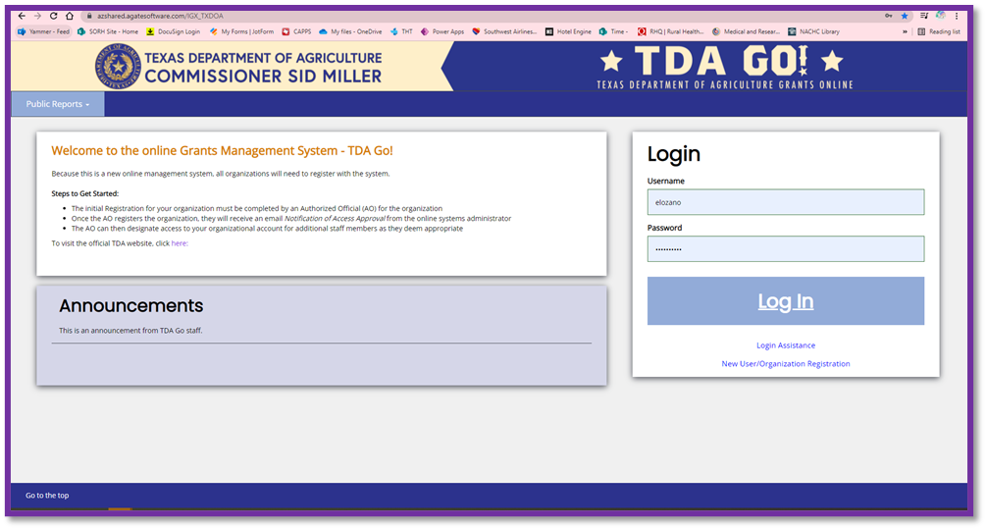
Figure 2.
TDA GO! Home page

DASHBOARD

After logging in, your organization’s Dashboard will appear (Figure 3). In the My Tasks section you will find your 2022 SHIP application. You can also view your profile and check for accuracy. Much of the profile for both the hospital organization and each individual system user has been prefilled for you. Please click on each profile tab and double check ALL FIELDS for accuracy of information (Figure 4). The Profile tab is located under your name in the upper righthand corner.

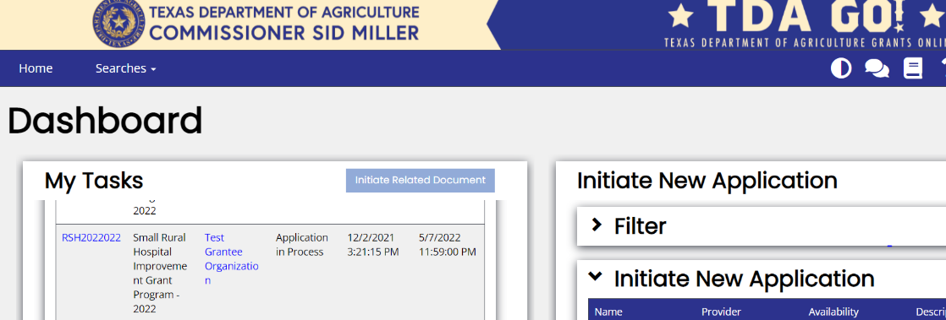

Figure 3. Dashboard Page

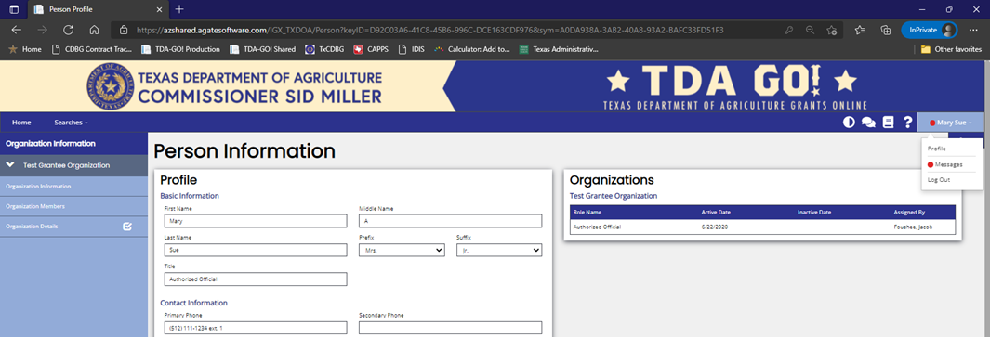

Figure 4. Profile Page

In the My Tasks section of the Dashboard, as shown above in Figure 3, click on the application ID (name) RSH2022### and this will take you to the Document Landing Page where your application is housed. Again, please note that while completing the application you may save it by clicking the Save button at the top right side of the application (Figure 5). It will appear on in the My Tasks section of your Dashboard and you may reopen it at any time in the process.
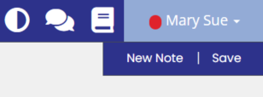

Figure 5. Save Button

DOCUMENT LANDING PAGE
Note: When in any stage of the application you may click on the application ID and view the Document Landing Page (Figure 6). The application ID is also your grant number and will appear on the app, contracts, reports, etc. The Application page is where you are taken once you select an application to view. The navigation bar on the left side of the page includes sections for:
- Application ID/Name – contains grant, organization, due date, status, role being performed, etc.
- Forms – contains the Application Contact Information, Application, and Certification forms.
- Status Options – contains the submission and cancel applications buttons
- Tools – contains add/edit people, status history, attachment repository, etc.
- Related Documents
Figure 6. Document Landing Page
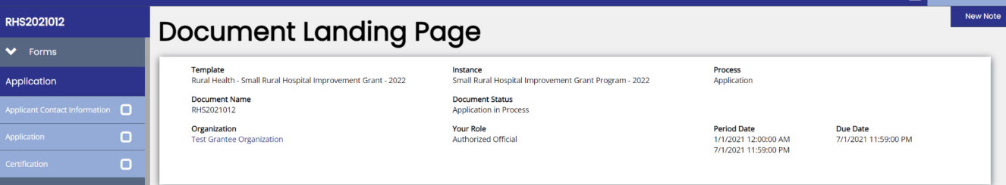

APPLICANT CONTACT INFORMATION

Much of the Applicant Contact Information has been prefilled for you. Please click on this tab and double check ALL FIELDS for accuracy of information. Note: When you are completing this section, some fields may autofill. This is connected to information in your computer’s autofill function so please check any fields that auto populate to make sure the correct information is entered. If any corrections are needed, please notify your RHC immediately.
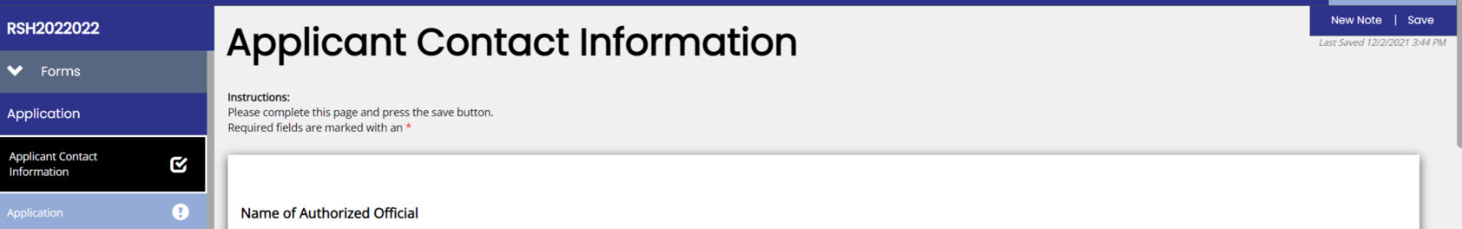

Figure 7. Next Form Button

After completing the review of the Applicant Contact Information page, click on the Next Form button at
the bottom of the page (Figure 7).

Note: As you complete each section a check mark will show up next to it on the navigation tab on the left side (Figure 8).
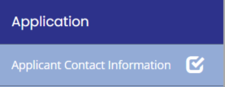
Figure 8. Completion Check

APPLICATION
Click on the Application navigation tab and it will bring you to the main body of the application (Figure 9). Some of this information is preloaded for you. Please verify it for correctness. If there are errors, notify your RC immediately so it can be fixed. Remember, if there is a field that requires text and you have none to enter please put N/A.

Please complete all sections of the application. If you do not and you try to certify and submit
the application the system will not allow you to do so. A window will pop up that tells you what remains to be completed (Figure 10).

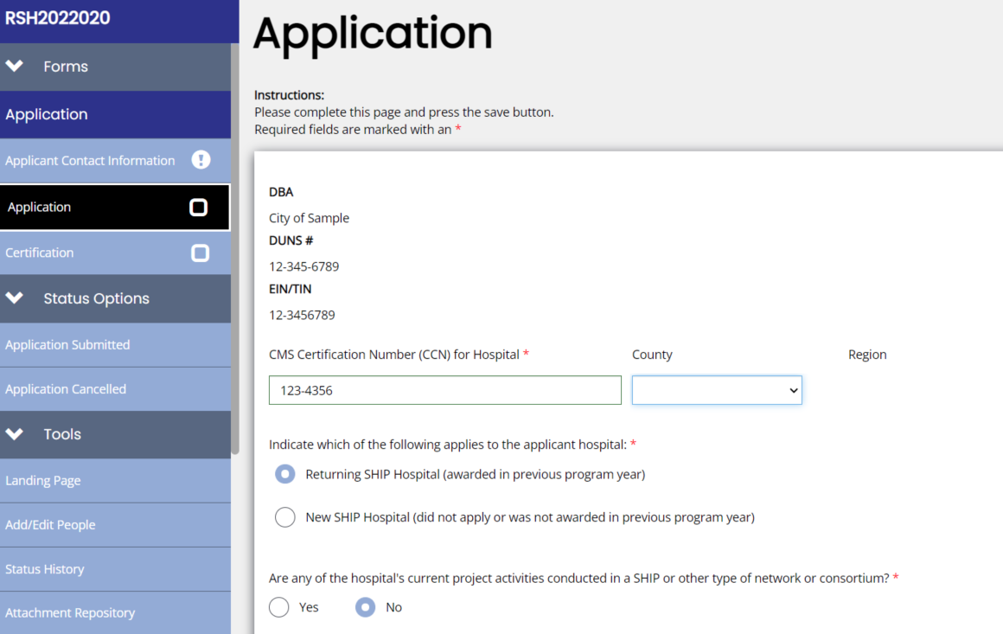

5
Figure 9. Application

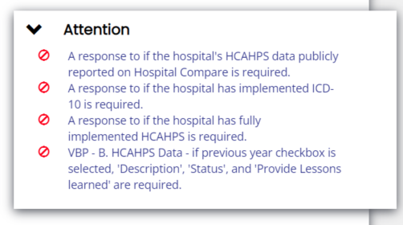

Figure 10. Error Pop-Up Window

Remember: You can toggle back and forth between pages with the Previous and Next Form buttons at the bottom of the page. When you toggle either way the system will automatically save any entries you have made.

Medicare Cost Report Question – Please remember to complete this step to download the information below to certify the hospitals number of beds (Figure 11).
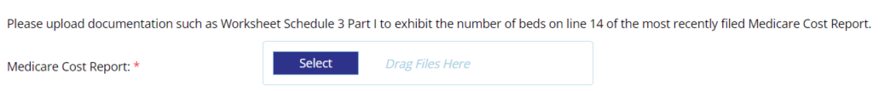
Figure 11. Medicare Cost Report Upload

- SHIP Activities Section – In this section, in the first two columns you will describe what you are doing for your current year project (2021-2022) and lessons learned, and in the third column you will describe what you plan to request for the 2022-2023 grant year project (Figure 12). The application contains this link which will give you the full name and description of each activity category. Allowable and Unallowable Investment Activity Examples

When a text box is required but is not applicable, please put NA in the text box or an error
window will pop up and reflect that the section is not complete.
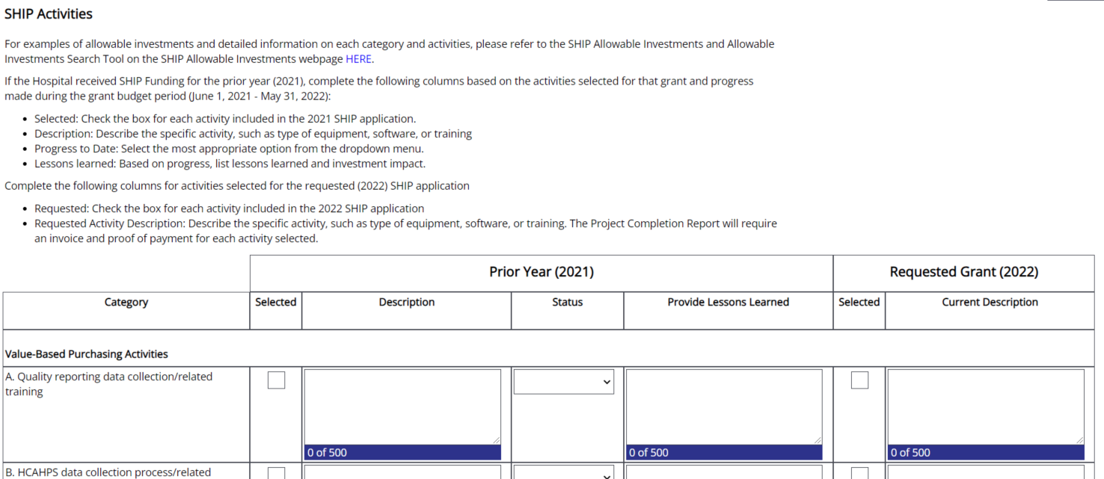

Figure 12. SHIP Activities

- SHIP Purchasing Category Table – In this section you will put in the dollar amount you are requesting for each of the categories for which you are selecting to be funded (Figure 13.) You may ask for all of the funds for one or more of the categories. The dollar amount you put in each category will automatically populate the percentage of the funding is used. The percentage must total to $12,836.00 or you will not be able to submit the application.

If you are not requesting funds from a category please put a Ø in the Budget Request column. If you do not do this an error box will popup when you save the document.
Click the Next Form button to be taken to the Certification page.
Figure 13. Example: SHIP Purchasing Category Table
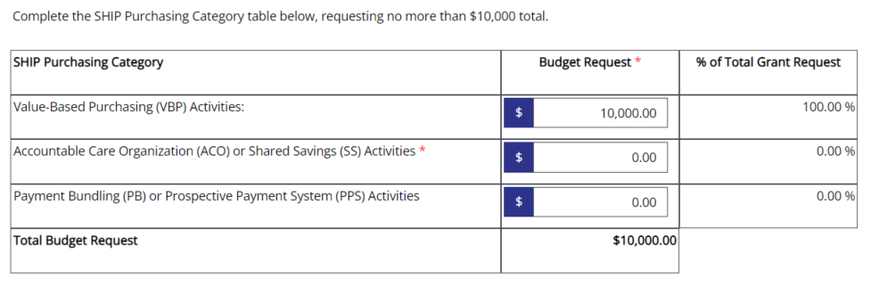

CERTIFICATION

This page is where the Authorizing Official of the hospital electronically signs the document (Figure 14). After the Authorized Official has completed the Certification Page, click the Save button on the top righthand side of the page (Figure 15). The last step is submission, see below.

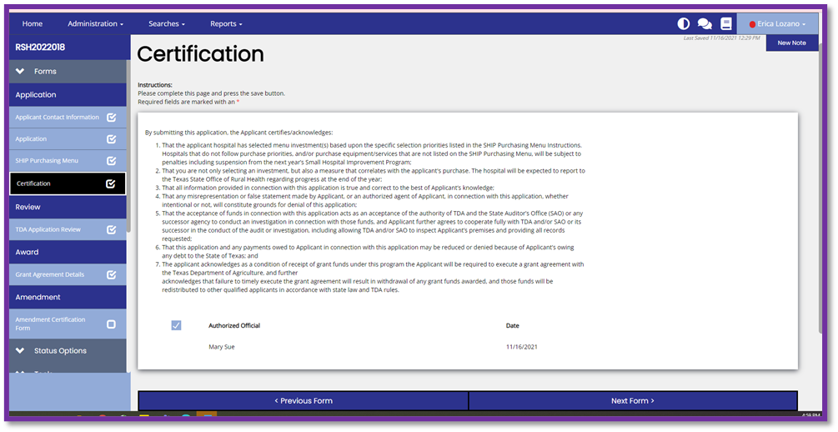

Figure 14. Certification

Figure 15. Save Button

THE FOLLOWING PAGE SHOWS THE FINAL SUBMISSION STEP!
Application will not be submitted unless this step is completed!
APPLICATION SUBMISSION

Once the application is completed, certified and saved by the Authorizing Official, the Authorizing Official must submit the application within the TDA-GO system. The application then goes from Application in Progress to Application Submitted.
- In the menu on the left of the page, select Application Submitted (Figure 16)
- The system will identify any errors that must be resolved before submitting (Figure 17)
- The system will ask if you are sure—you are so click OK! (Figure 18)
- The application is now submitted. A Status Change Message box will pop up and will say This Application’s status has been updated to Application Submitted (Figure 19). It will be visible and accessible in in your organization’s Dashboard in the My Task section.
- After the application due date has passed the application will enter the reviewing process. Notification of the award will be in the Spring of 2022.

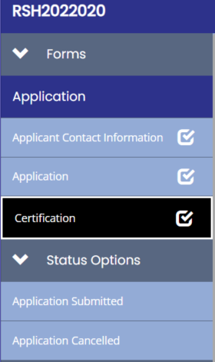
Figure 116. Application Submitted Navigation Tab

Figure 17. Error Pop-Up Window

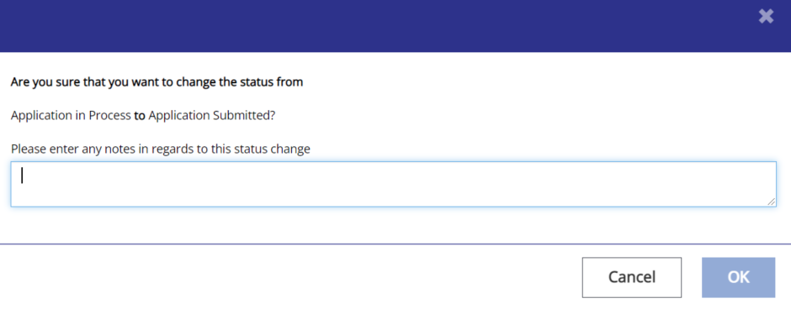

Figure 18. Are You Sure?

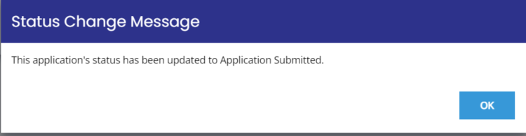
Figure 19. Status Change Message Application Submitted!

APPENDIX

Hospital Roles within the TDA GO! system

- Authorized Official – Can prepare, certify and submit applications.
- Project Director – Can prepare an application but cannot certify and submit unless otherwise arranged by the Authorized Official.

